Dorothy Mae (Grows) Smith

Abt. 1945 – March 11, 2022

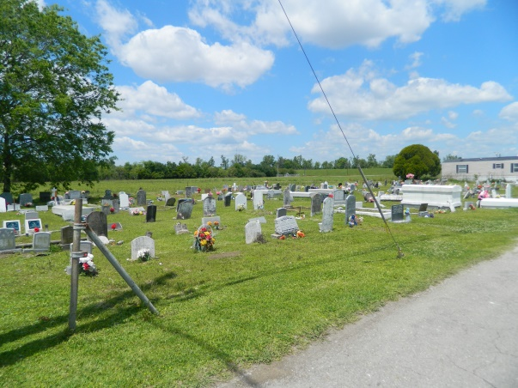

Dorothy Mae Grows "Daw" Smith at the age of 77, departed this earthly life and entered into eternal rest on March 11, 2022 at Ochsner Kenner Regional Hospital in Kenner, LA. Daughter of the late Louis and Cora Grows. Beloved wife of the late Freddie Smith. Loving mother of Karen Johnson, Anthony Smith, Allen Smith, Sr., and Felicia Smith. Sister of Elouise Stockman, Annie Mae Populis, and Frances Williams. Grandmother of 10 grandchildren; great-grandmother of 2. Also survived by a host of nieces, nephews, other relatives, and friends. Preceded in death by her parents, the late Louis and Cora Grows; her husband, the late Freddie Grows; 3 sisters, 6 brothers, and 1 grandson. Pastors, officers, and members of Second African Baptist Church of Edgard, LA and all neighboring churches are invited to attend the homegoing celebration on Saturday, March 19, 2022, at 11 a.m. at Second African Baptist Church, 136 West 3rd St., Edgard, LA 70049. Pastor Clarence Z. Mollaire and Rev. Welman Jackson are officiating. Burial will be at Young Cemetery in Edgard, LA. Visitation will be at the above-named church until service time. Viewing will be held Friday, March 18, 2022, from 3 p.m. to 6 p.m. at Bardell's Mortuary, 3856 LA-44, Mt. Airy, LA 70076. In accordance with CDC guidelines for Covid 19, all in attendance must wear masks and practice social distancing. Service entrusted to Bardell's Mortuary. Information: (985)535-6837.

Published by The Advocate (Baton Rouge, LA) from Mar. 16 to Mar. 19, 2022.