Freddie Smith
February 26, 1913 – December 10, 1984
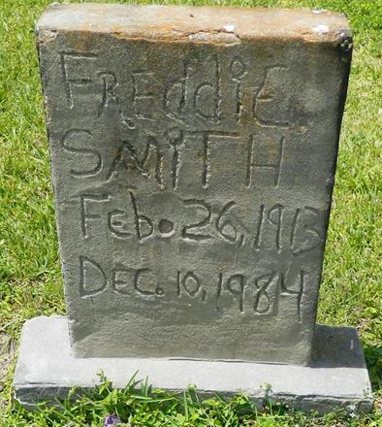

EDGARD – Freddie “Cussy” Smith, 58, a native and resident of Edgard, died Sept. 15. He was the husband of Dorothy Grows-Smith and father of Jarita Julien, Karen, Felicia, Anthony and Allen Smith Sr. and Joshua Johnson. He was the brother of Ernestine Traylor, Gerald Hebert and Gary Smith. He is survived by nine grandchildren. He was a former employee of Caire & Graugnard in Edgard. Services are today at 11 a.m. at Second African Baptist Church, Edgard, with interment at Young’s Cemetery, Edgard. Visitation starts at 9 a.m.

L’Observateur, Laplace, Louisiana
Sunday September 23, 2001

