Larry Stockman Jr.

Abt. 1981 – January 6, 2000

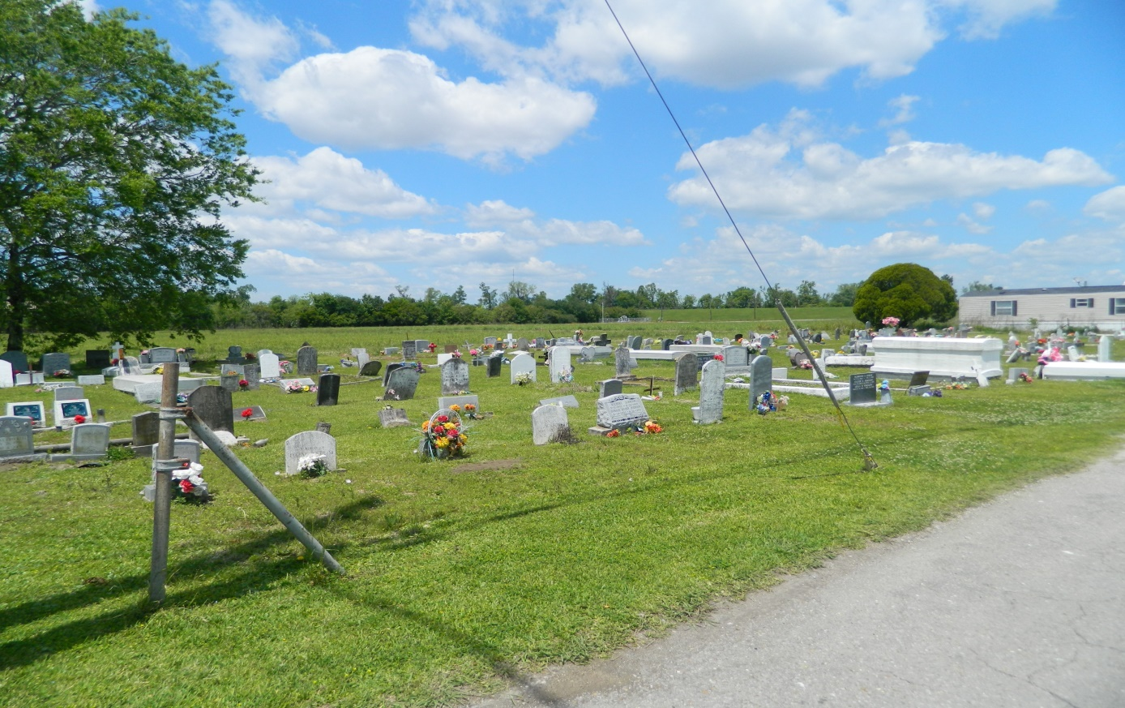

EDGARD - Larry Stockman Jr., 19, a native of Edgard and resident of LaPlace, died Jan. 6. He was the son of Elouise Grows Stockman and the late Larry Stockman Sr. and brother of Stephanie Howard, Dana, Mark, Jada and Vada Stockman and the late Marsha and Cassandra Stockman. Services were held Jan. 10 at Second African Baptist Church, Edgard, with interment at Young Cemetery, Edgard.

**L'Observateur, LaPlace, LA; January 12, 2000**