Jessie J. Taylor
October 30, 1940 – February 16, 2004

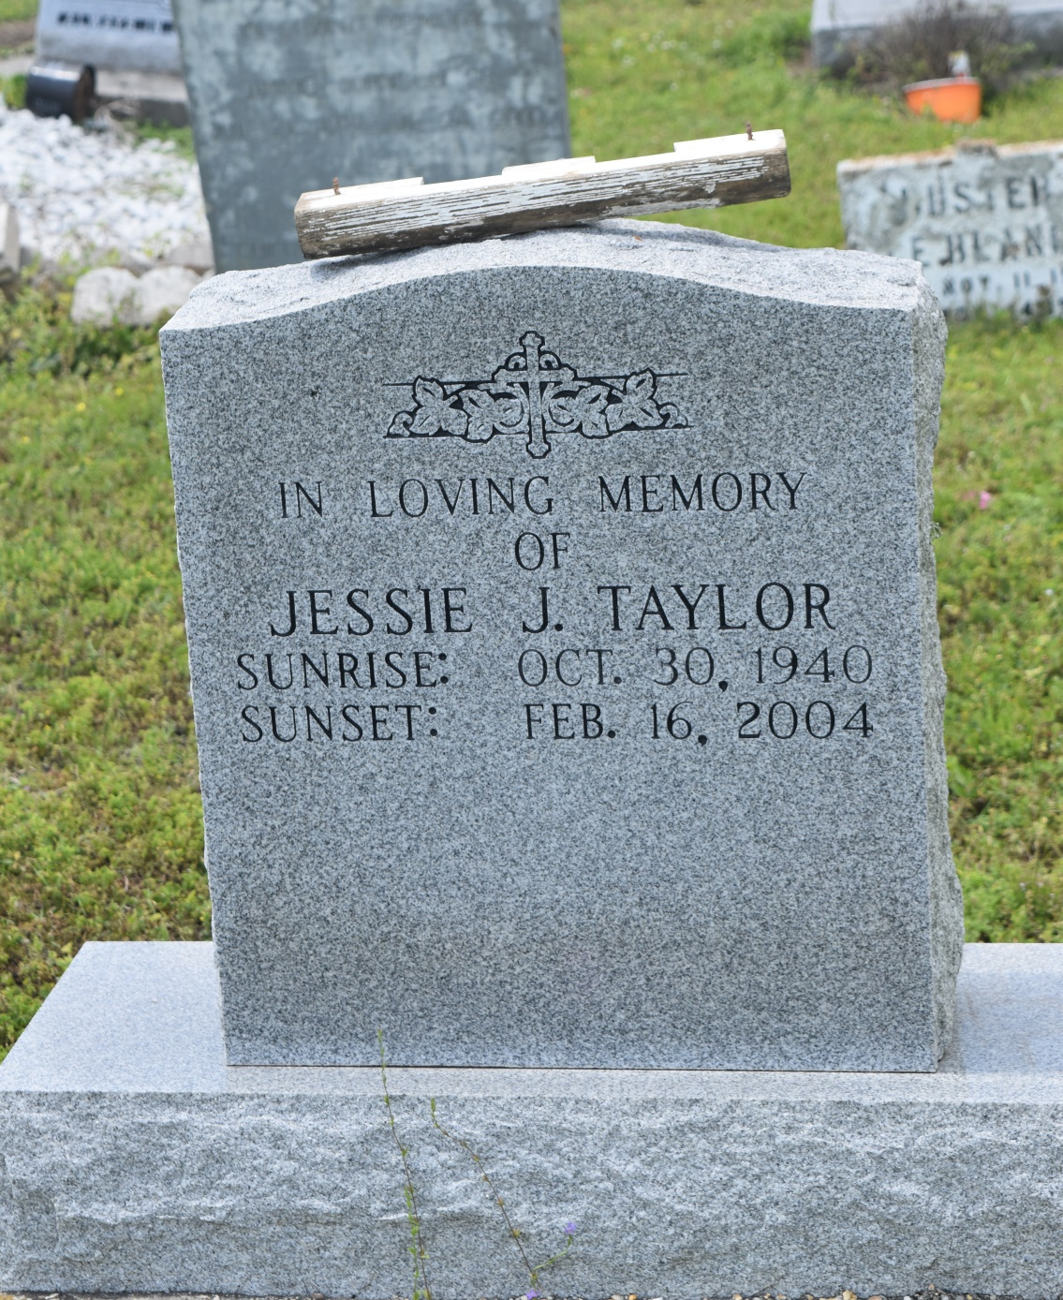

Jessie J. Taylor, a retired offshore worker for Odeco Offshore Drilling, died Monday of a heart attack at Memorial Medical Center. He was 63. Mr. Taylor was born in Silvercreek, Miss., and lived in New Orleans for most of his life. He was a member of Third Rose of Sharon Baptist Church. Survivors include his wife, Corita Lewis Taylor; two stepsons, Matthew and Ulysess Joseph; three stepdaughters, Gilda Woods, Mary Rounds and Shirley Dorsey; a brother, Alfred Taylor; 16 grandchildren; and 10 great-grandchildren. A funeral will be held Saturday at 11 a.m. at Third Rose of Sharon Baptist Church, 2132 Third St. Visitation will begin at 10 a.m. Burial will be in Young Cemetery in Edgard. Estelle J. Wilson Funeral Home is in charge of arrangements.

Times-Picayune, The (New Orleans, LA) - Wednesday, February 18, 2004
Contributed by Jane Edson

