Alzeria Valentine Jr.

Abt. 1935 – February 3, 2001

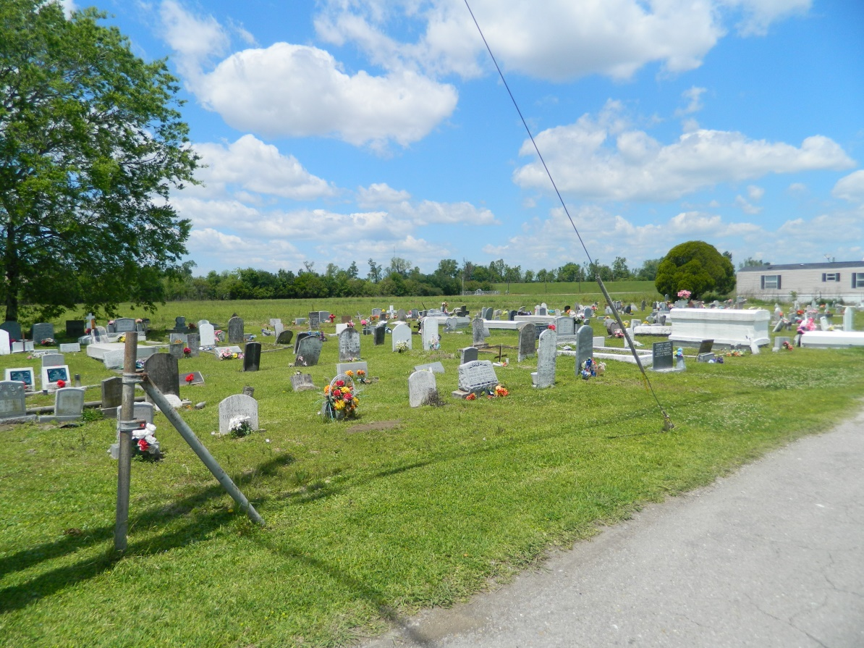

VALENTINE

EDGARD - Alzeria Valentine Jr., 66, a native of Edgard and resident of New Orleans, died Feb. 3. He was the husband of Cenovia Johnson Valentine and father of Sandra James, Carla Cyprien and Ricky and Glenn Valentine. He was also the son of the late Alzeria and Albertha Valentine and brother of Shirley Coleman, Dorothy Milton and Juanita, Shelton, Jacob, George and the late Augurfur Valentine. He is also survived by eight grandchildren. Services are today at 11 a.m. at Greater New St. Peter Baptist Church, Edgard, with interment at Young Cemetery, Edgard. Visitation starts at 9 a.m.

**L'Observateur, LaPlace, LA; February 7, 2001**