Semonia (Young) Young

Abt. 1908 – December 7, 2000

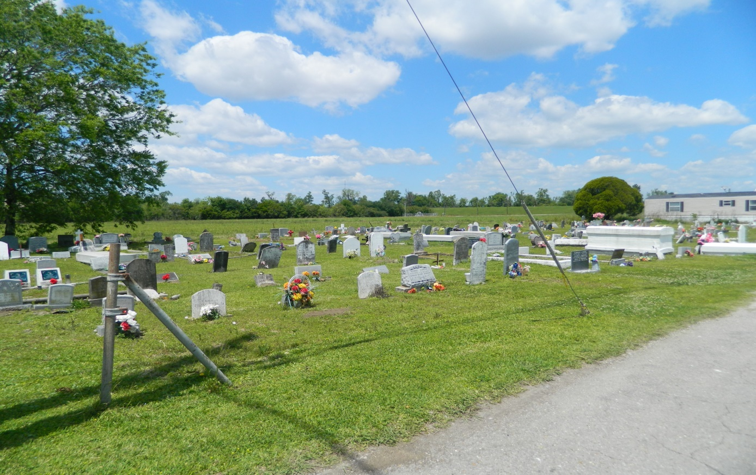

EDGARD - Semonia Young, 92, a native and resident of Edgard, died Dec. 7.She was the wife of the late Willis Young Sr. and mother of Thelma Turner, Irma Roussell, Shirley Mason, Lutha Mason, Lillie Johnson, Willis Jr. and Alfred Young and the late Lucille Favorite. She was also the daughter of the late Eugene and Lucille Young and sister of Geneva Smith, Victor Lumar and the late Lorenza Fiffie, Lucretia Jones and Otis, Adrian and Eugene Lumar Jr. She is also survived by 42 grandchildren, 105 great-grandchildren and 18 great-great-grandchildren.

Services were Dec. 11 at Greater New St. Peter Baptist Church, Edgard, with interment at Young

Cemetery, Edgard. L'Observateur / December 13, 2000

**L'Observateur, LaPlace, LA; May 19, 2000**