Ernest Richard Davis
August 22, 1946 – April 20, 2004

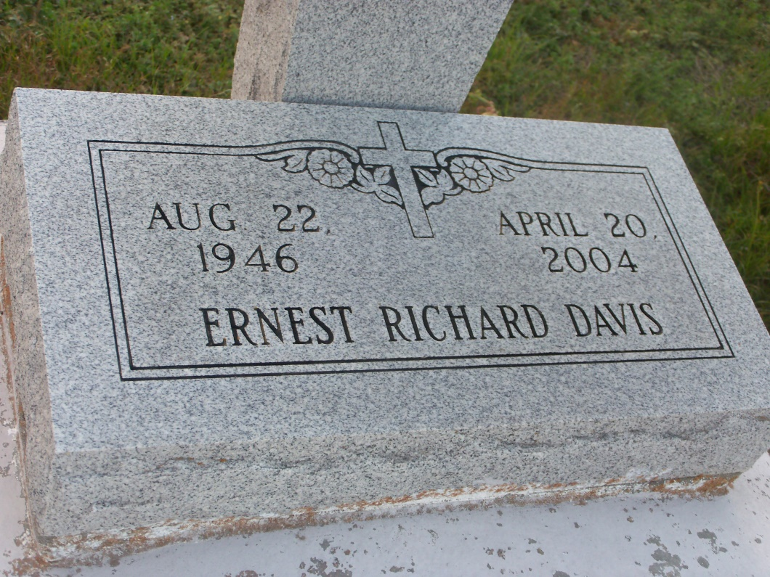
Photo by GeniHound

Ernest Richard "Steelchest" Davis at his residence in Reserve, LA on Tuesday, April 20, 2004 at 5:35 p.m. Beloved husband of Christina Marie Green Davis. Father of Adrian Ann D. Walker. Brother of Ellis D. Perrilloux. Nephew of Lena West of Chicago, IL. Son-in-law of Lillie Mae Green of Dallas, TX. Son of the late Ellis and Lillie West Davis. Also survived by four grandchildren: Dontrielle Davis, Christiana, Allicyn and Donald Walker, Jr.; and a host of nieces, nephews, relatives and friends. Age 57 years. A lifelong resident of Reserve, LA.
Relatives and friends of the family, also pastor, officers and members of the Greater New Plymouth Rock Baptist Church, all neighboring churches, Riverbend Lanes Bowling Leagues, former employees of Godchaux Henderson Sugar Refinery and employees of Bayou Steel, U.S. Department of Veteran Affairs Regional Office, Kenner Super Walmart, Fifth Ward Elementary School are all invited to attend the funeral services from the Greater New Plymouth Rock Baptist Church, 110 Northwest 13th Street, Reserve, LA, Senior Pastor David B. Carter, officiating, on Saturday, April 24, 2004 12 noon. Visitation will begin at 10:00 a.m. until 11:45 a.m. Interment in Zion Travelers Cemetery, Reserve, LA.
The BALONEY FUNERAL HOME in charge of arrangements

Times-Picayune, The (New Orleans, LA) - Friday, April 23, 2004
Contributed by Jane Edson

