Rosalie (Love) Stephens
September 19, 1951 – May 5, 2003

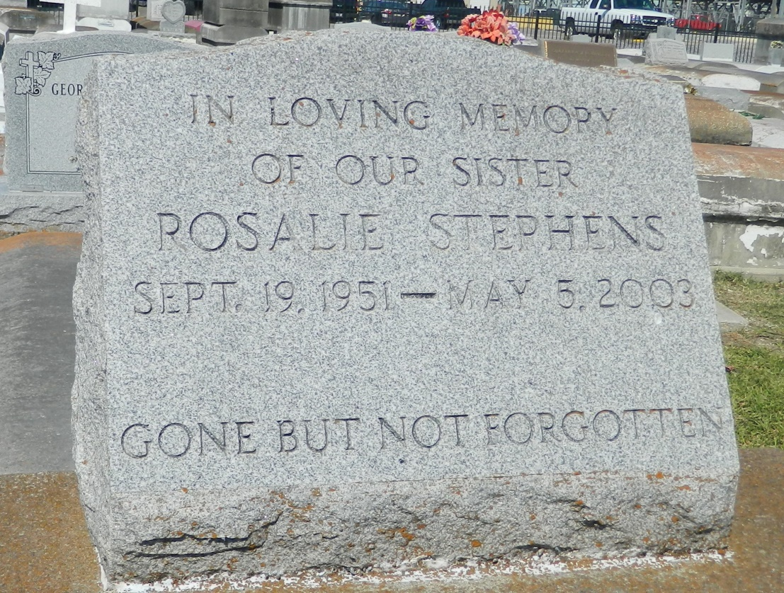

Rosalie Love Stephens, of Mt. Airy, La. at River Parishes Hospital, LaPlace, La on Monday, May 5, 2003. Daughter of Deloris Lemmon Love and the late Ernest Love. Sister of Alexander and Alfred Love of Mt. Airy, La., James Love of Convent, Rev. Henry Love of Vacherie, La, Charles Love of Gonzales, La., Clarence Love of LaPlace, La., Ernest Polk of Los Angeles, Ca., Bobbie Jean Love Gomes of St. Croix, V.I., Geraldine Love of Algiers, La. and the late Sharon Love and Ernestine Chambers. Sister-in-law of Lorraine Gilder, Donna and Erika Love, and Leo Gomes. Devoted friend of Mary Weber and Vivian Braxton. Also survived by (17) nieces and nephews, (5) great nieces and a host of other relatives and friends. A native and resident of Mt. Airy, La. Age 51 years.
Relatives and friends of the family, also pastor, officers, members of the St. John Bapt. Church, First Bapt. Church-Vacherie, and neighboring churches, are invited to attend the funeral services on Monday, May 12, 2003 at 11:00 AM from the St. John Bapt. Church, Mt. Airy, La. Rev Gary Bolden Sr. officiating. Interment Zion Travelers B.C. Cemetery. Reserve, La. Visitation at the church after 10:00 AM.
The Baloney Funeral Home in Charge Of Arrangements.

Times-Picayune, The (New Orleans, LA) - Sunday, May 11, 2003
Contributed by Jane Edson

