Vincent Zachary Thomas Jr
February 1, 1994 – October 16, 2006

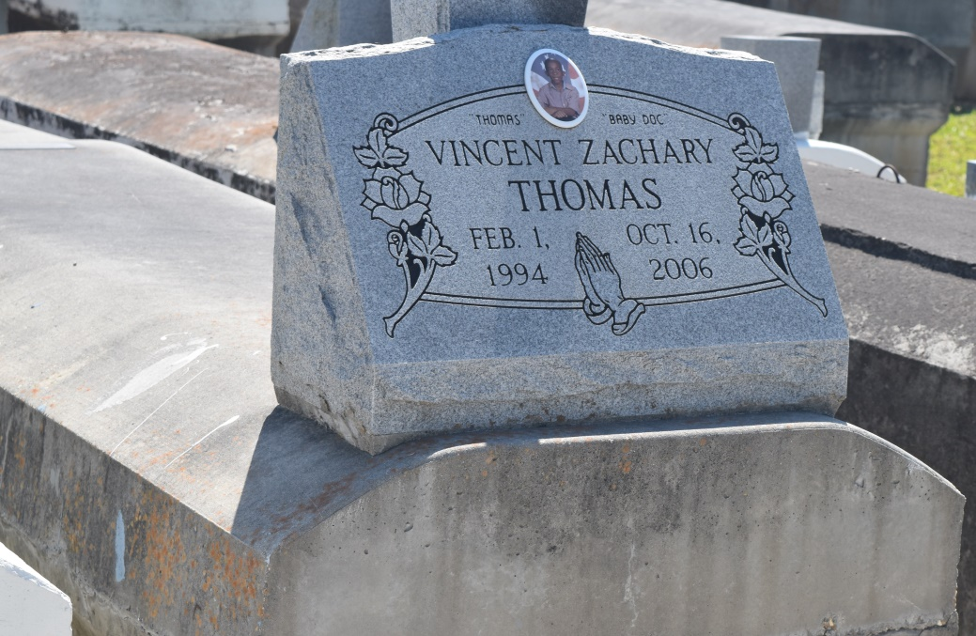

Vincent Zachary Thomas, Jr., departed this life on Monday October 13, 2006 at River Parishes Hospital Laplace, La., Son of Ann Marie Preston and Vincent Zachary Thomas, Sr., Brother of Ayonte' Thomas, Antonio Denson, and Jordan Carter, Grandson of Nolan and Gussie Preston, Altheia and Richard Keller and Victor Thomas, also survived by 6 Aunts, 12 Uncles and a host of great aunts, and uncles, cousins, other relatives and friends. Age 12.
Pastor, Officers and Members of Mt. Zion Baptist #1 Church, Providence B.C. and all neighboring churches, Staff, Faculty and student body of Fifth Ward Elementary School are invited to attend service on Friday October 20, 2006 at 11:00 a.m., 144 Little Hope St. Garyville, La., Rev. Arthur Joseph, Officiating Pastor, Interment Zion Travelers Cem. Reserve, La., Viewing at the funeral home on Thursday from 5:30 p.m. until 7:00 p.m. and on Friday from 9:00 a.m. Until service time at the church.
Service Entrusted to Hobson Brown Funeral Home, Garyville, LA.

Times-Picayune, The (New Orleans, LA) - Thursday, October 19, 2006
Contributed by Jane Edson

