Pvt. Walter J. Bergeron
July 18, 1922 – July 30, 1944

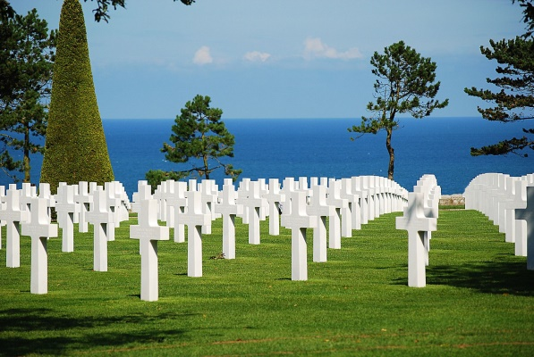

American Battle Monuments Commission

World War II Purple Heart

Service # 38309494
Unit 2nd Infantry Regiment, 5th Infantry Division
Rank Private U.S. Army
Entered Service From Louisiana
Date of Death July 30 1944
Buried Plot H Row 25 Grave 35
Normandy American Cemetery
14710 Colleville-sur-Mer, France

