Staff Sargeant Peter Caravella
June 19, 1917 – November 24, 1944

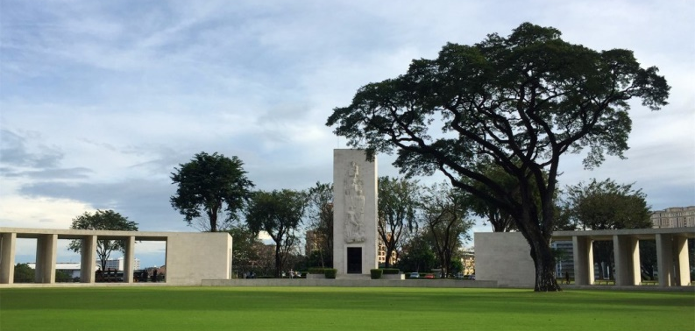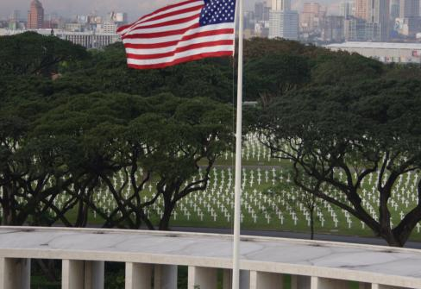

American Battle Monuments Commission

World War II Purple Heart Air Medal

Service # 38194013
Unit 75th Bomber Squadron, 42nd Bomber Group, Medium
Rank Staff Sergeant U.S. Army Air Forces
Entered Service From Louisiana
Date of Death November 24 1944
Status Missing In Action
Memorialized Walls of the Missing
Manila American Cemetery, McKinley Road, Fort Bonifacio, 1634, Philippines

