Cpl. Alfred J. Chapoton, Jr.
August 22, 1912 – October 10, 1944

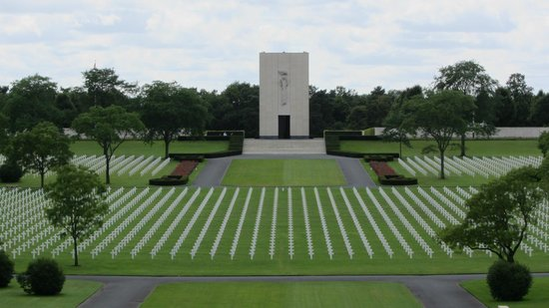

American Battle Monuments Commission

World War II Purple Heart

Service # 14015775
Unit 654th Tank Destroyer Battalion
Rank Corporal U.S. Army
Entered Service From Louisiana
Date of Death October 10 1944
Buried Plot C Row 23 Grave 16
Lorraine American Cemetery
Avenue de Fayetteville, 57500, St Avold, France

