Cpl. Lionel T. Hymel
April 11, 1920 – March 13, 1945

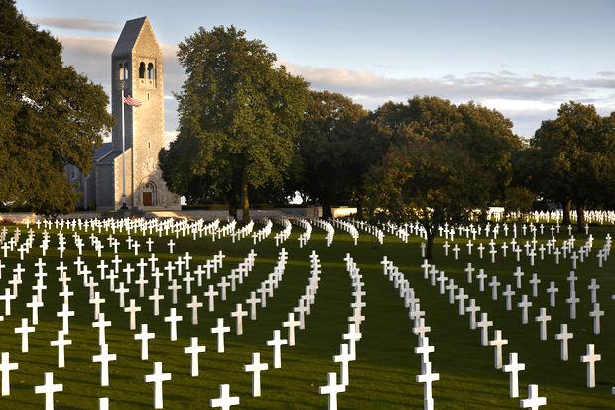

American Battle Monuments Commission

World War II

Service # 34152520
Unit US Infantry
Rank Corporal U.S. Army
Entered Service From Louisiana
Date of Death March 13 1945
Status Missing In Action
Memorialized Tablets of the Missing
Brittany American Cemetery
Bel Orient, 50240 Montjoie Saint Martin, France

*****
Corporal Lionel Thomassin Hymel was killed in action, while en route to combat operations in the European Continent among a convoy of Allied ships, on the U. S. Army Transport (USAT) J. W. McAndrew. At approximately 0400 hours on the morning of 13 March 1945, the ship was struck by the French Aircraft Carrier Bearn, which had become off course due to mechanical failure. A gaping hole opened up in the No. 1 hold where one hundred and thirty-four enlisted men were quartered. Sixty-eight men were lost at sea, including Corporal Hymel. Thirteen men were rescued from the very cold waters by two destroyers in the convoy.
Contributed by B24CoPilotNiece

