PFC Sidney Richard Johnston Jr.
April 17, 1911 – April 5, 1943

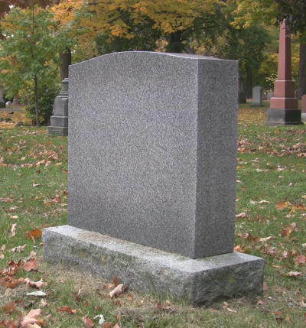

U.S., World War II Army Enlistment Records, 1938-1946

Name: Sidney R Johnston Jr
Race: White
Marital status: Single, without dependents
Rank: Private
Birth Year: 1911; Nativity State or Country: Louisiana
Residence: St John The Baptist, Louisiana
Education: 4 years of college
Civil Occupation: General industry clerks
Enlistment Date: 10 Oct 1942; Enlistment Place: New Orleans, Louisiana
Service Number: 38313237
Branch: Branch Immaterial - Warrant Officers, USA
Component: Selectees (Enlisted Men)
Source: Civil Life
Height: 70; Weight: 135
*****

California, U.S., Death Index, 1940-1997

Name: Sidney Richard Johnston
Gender: Male
Birth Date: 17 Apr 1911; Birth Place: Louisiana
Death Date: 5 Apr 1943; Death Place: Los Angeles
*****

U.S., Headstone Applications for Military Veterans, 1925-1970

Name: Sidney R Johnston Jr
Service Number: AS,N38313237
Unit: Air Corps, 210th J.S.S.; attached to Am. School, Aircraft Instrumenty
Enlistment Date: 10 Oct 1942
Discharge Date: 5 Apr 1943
Death Date: 5 Apr 1943
Cemetery: Roselawn Memorial Park, Baton Rouge, Louisiana, USA

