Sgt. Larry Norman Lasseigne
September 17, 1925 – March 5, 1945

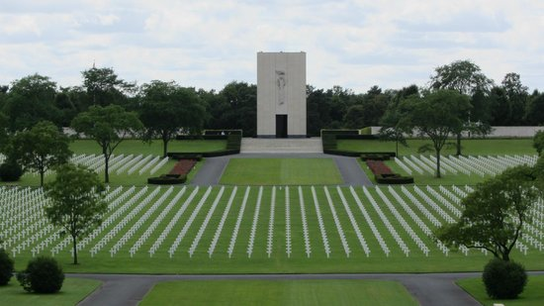

American Battle Monuments Commission

World War II Purple Heart

Service # 38501193
Unit 302nd Infantry Regiment, 94th Infantry Division
Rank Sergeant U.S. Army
Entered Service From Louisiana
Date of Death March 5 1945
Buried Plot K Row 21 Grave 21
Lorraine American Cemetery
Avenue de Fayetteville, 57500, St Avold, France

