PFC Marcel J. Madere
August 20, 1916 – February 17, 1945

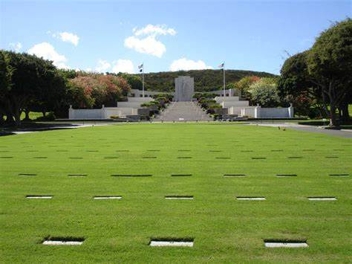
National Memorial Cemetery of the Pacific
Hawaii

Stone Inscription:

Marcel J Madere
Louisiana
PFC 364 AAF Air Service Group
World War II
Aug 20, 1916 – Feb 17, 1943
N478

