Pvt. Robert Joseph Michel, Jr.
May 28, 1920 – April 17, 1942

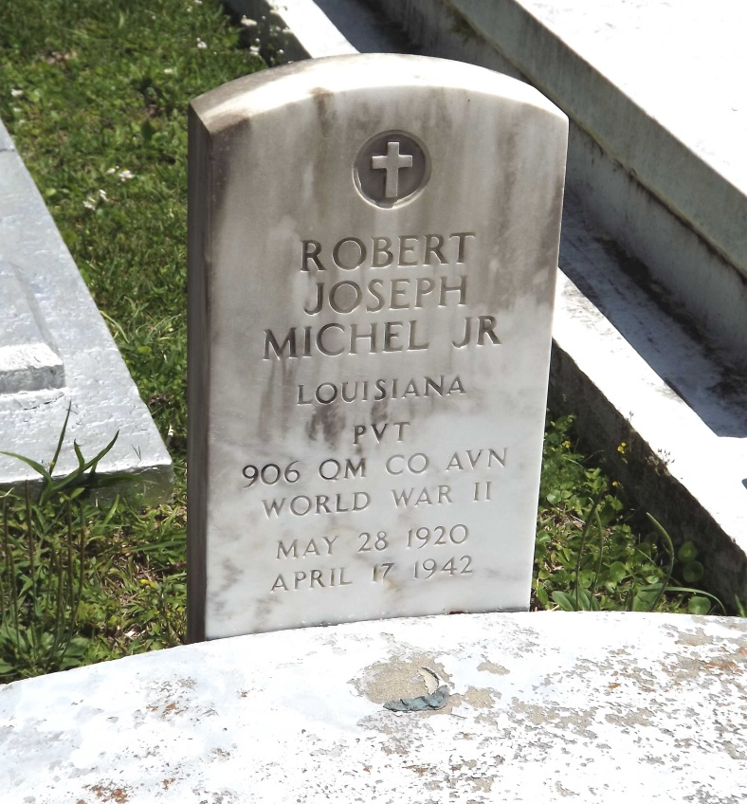
Photo by Mary Agnes Hammett

U.S., World War II Army Enlistment Records, 1938-1946

Name: Robert J Michel Jr
Race: White
Marital status: Single, without dependents (Single)
Rank: Private
Birth Year: 1920
Education: 2 years of high school
Civil Occupation: Unskilled occupations in production of misc. food products
Enlistment Date: 11 Oct 1941
Enlistment Place: Jacksonville Army Air Field, Florida
Service Number: 34152522
Branch: Branch Immaterial - Warrant Officers, USA
Component: Selectees (Enlisted Men)
Source: Civil Life
Height: 66; Weight: 150
*****

U.S., World War II Hospital Admission Card Files, 1942-1954

Name: Robert J Michel
Gender: Male; Race: White/Mexican (White)
Rank: Enlisted Man
Admission Age: 20
Birth Date: abt 1922; Birth Place: Louisiana
Admission Date: Apr 1942; Admission Place: Keesler Fld., Biloxi, Mississippi
Discharge Date: Apr 1942
Military Branch: Quartermaster
Diagnosis: CausativeAgent: Motor vehicle, passenger
Injured in Line of Duty: In line of duty
Length of service: 5 - 6 months
Service Number: 34152522
*****

U.S., Headstone Applications for Military Veterans, 1925-1970

Name: Robert Joseph Michel Jr
Birth Date: 28 May 1920
Service Number: 34 152 522
Unit: Det. 906th Q.M. Co Aviation (Service) Quartermaster Corps
Enlistment Date: 11 Oct 1941
Death Date: 17 Apr 1942, near Ponchatoula, Louisiana
Cemetery: St Michael's Cemetery
Cemetery Location: Convent, St. James Parish, Louisiana, USA

