Sgt. Raymond Henry Millet
June 12, 1921 – December 5, 1944

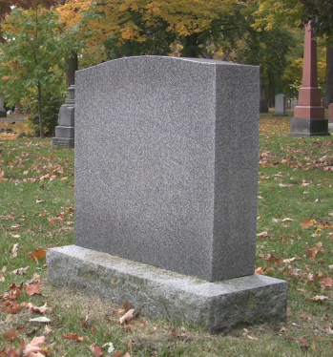

DIED OF WOUNDS

New Orleans – MILLET, Raymond, Sgt., in Germany; wife Mrs. Rita C. Millet, New Orleans; parents, Mr. and Mrs. Sam Millet, Lions, La.

The Times-Picayune, New Orleans, LA, 15 Jan 1945, p. 7
*****

U.S., World War II Army Enlistment Records, 1938-1946

Name: Raymond H Millet
Race: White
Marital status: Married
Rank: Private
Birth Year: 1920
Education: 4 years of high school
Enlistment Date: 6 Dec 1941; Enlistment Place: Jacksonville Army Air Field, FL
Service Number: 34155172
Branch: Branch Immaterial - Warrant Officers, USA
Component: Selectees (Enlisted Men)
Source: Civil Life
Height: 71; Weight: 140
*****

New Orleans, Louisiana, U.S., Marriage Records Index, 1831-1964

Name: Raymond H Millet
Marriage Date: Oct 1941
Marriage Place: New Orleans, Orleans, Louisiana, USA
Spouse: Rita Mae Cordilla
*****

US, National Cemetery Interment Control Forms, 1928-1962
Millet, Raymond H, Sgt
Serial # 34155172
Birth June 12, 1921
Death Dec 5, 1944
Interment 2/8/1949
Cemetery Alexandria National Sect. E#14, Pineville, LA

