PFC Vince C. Palermo
1921 - January 14, 1945

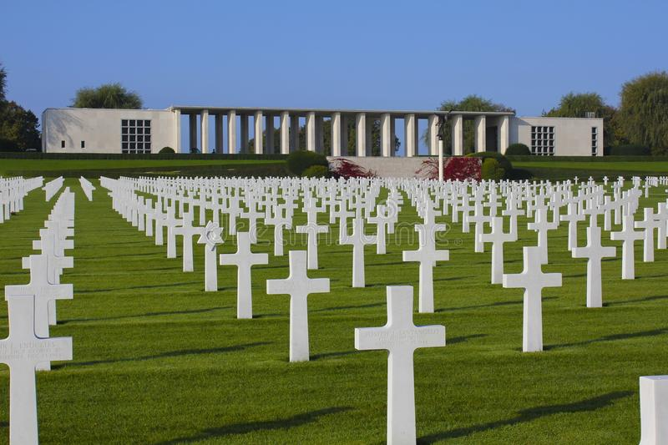

American Battle Monuments Commission

World War II Purple Heart

Service # 38313246
Unit 63rd Infantry Battalion, 11th Armored Division
Rank Private First Class U.S. Army
Entered Service From Louisiana
Date of Death January 14 1945
Buried Plot H Row 15 Grave 4
Henri-Chapelle American Cemetery, 159, rue du Mémorial Américain 4852, Hombourg, Belgium
*****

U.S., World War II Army Enlistment Records, 1938-1946

Name: Vince C Palermo
Race: White
Marital status: Single, without dependents (Single)
Rank: Private
Birth Year: 1921; Nativity State or Country: Louisiana
Citizenship: Citizen; Residence: St John The Baptist, Louisiana
Education: Grammar school
Civil Occupation: Packing, filling, labeling, marking, bottling, and related occupations, n.e.c.
Enlistment Date: 10 Oct 1942; Enlistment Place: New Orleans, Louisiana
Service Number: 38313246
Branch: Branch Immaterial - Warrant Officers, USA
Component: Selectees (Enlisted Men); Source: Civil Life
Height: 66; Weight: 114

