2nd Lt. Joseph L. Schexnayder
July 5, 11919 – November 13, 1943

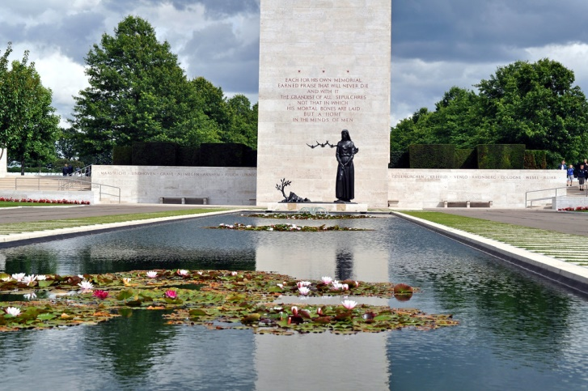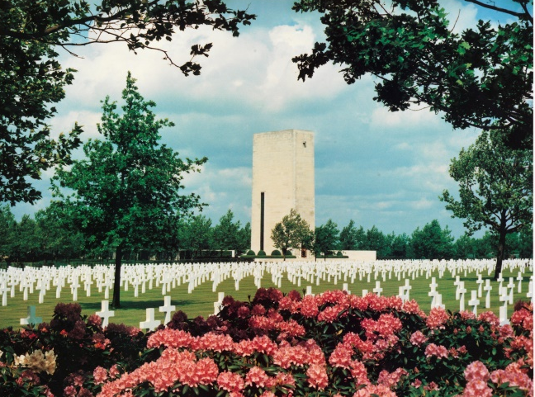

American Battle Monuments Commission

World War II Purple Heart Air Medal

Service # O-684807
Unit 66th Bomber Squadron, 44th Bomber Group, Heavy
Rank Second Lieutenant U.S. Army Air Forces
Entered Service From Louisiana
Date of Death November 13 1943
Status Missing In Action
Memorialized on Tablets of the Missing
Netherlands American Cemetery, AM Begraafplaats 1, 6269 NA, Margraten, Netherlands
*****

USAAF WORLD WAR II
Navigator 2nd/Lt. Joseph L. Schexnayder MIA/KIA
Hometown: Garyville Louisiana
Squadron: 66th 44th Bomb Group
Target: Bremen, Germany; Mission Date: 13-Nov-43
Serial Number: #42-40973; Aircraft Model B-24; Aircraft Name:BATTLEAXE
Cause: Crew of 10 5KIA 5MIA/KIA

Lt. Harlan C. Almlie was the pilot of this 66th Squadron aircraft. The Squadron reported that at the IP, slight inaccurate flak was encountered at 24,000 feet; bombs were away at 1147 hours. Over the target, flak was slight and inaccurate and fighter opposition slackened due to support of P-38s. From the target out to the coast, flak again was inaccurate, spasmodic. BATTLEAXE was last seen flying in a diamond formation with the Group to within 20 minutes from the English coast, one engine was smoking heavily, and the aircraft was gliding down under control. Air-Sea Rescue Service was notified as soon as crews were interrogated, but there were no eyewitnesses to a ditching or crash of this craft. It seems most likely that they ditched, as later bodies of two crew members were found and buried at Margraten, Netherlands. Five are listed on the Wall of the Missing. Three others were recovered and are buried in the United States.
BATTLEAXE Crew
Harlan C. Almlie Pilot Harlan C. Almlie Pilot
William E. Hacker Co Pilot Joseph L. Schexnayder Navigator
Walter J. Seiler Bombardier Donald A. Davis Engineer
Everett E. Permar Radio Op. George W. Iorgov Gunner
John V. Lundstrom Gunner John L Towning Gunner
Frederick A. Robinson Gunner

Contributed by John Dowdy

