SSgt. Camille A. Simon
February 16, 1917 – June 15, 1944

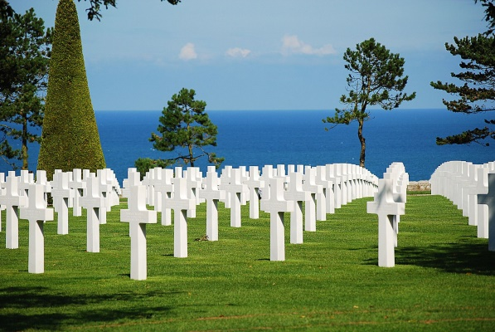

American Battle Monuments Commission

World War II Purple Heart

Service # 34005682
Unit 41st Infantry Battalion, 2nd Armored Division
Rank Staff Sergeant U.S. Army
Entered Service From Louisiana
Date of Death June 15 1944
Buried Plot E Row 21 Grave 37
Normandy American Cemetery
14710 Colleville-sur-Mer, France
*****

Sergeant Killed

Staff Sergeant Camille Simon, son of Mr. and Mrs. Sylvester Simon, Reserve, was killed in Action in France on June 15, according to a telegram from the war department. He had served in the North African and Sicilian campaigns during his two years’ service overseas.

Unknown newspaper clipping

