Pvt. Joseph A. Sutton
December 30, 1918 – January 30, 1944

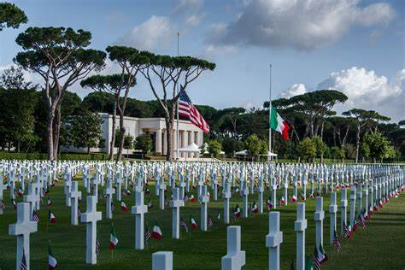

American Battle Monuments Commission

World War II Purple Heart Air Medal

Service # 38493340
Unit 168th Infantry Regiment, 34th Infantry Division
Rank Private U.S. Army
Entered Service From Louisiana
Date of Death January 30 1944
Buried Plot J Row 10 Grave 44
Sicily-Rome American Cemetery, Piazzale Kennedy, 1 00048, Italy
Nettuno, Lazio, Italy
*****

U.S., World War II Hospital Admission Card Files, 1942-1954

Name: Joseph A Sutton
Rank: Enlisted Man
Admission Age: 27
Birth Date: abt 1917
Admission Date: Jan 1944
Discharge Date: Jan 1944
Military Branch: Infantry, General or Unspecified
Diagnosis: FirstLocation: Thorax, generally; SecondLocation: Back, generally; CausativeAgent: None or Unknown
Type of Injury: Casualty, battle
Injured in Line of Duty: In line of duty
Type of Discharge: Died
Service Number: 38493340

