Jeffery Paul Accardo
July 12, 1967 - August 2, 2024

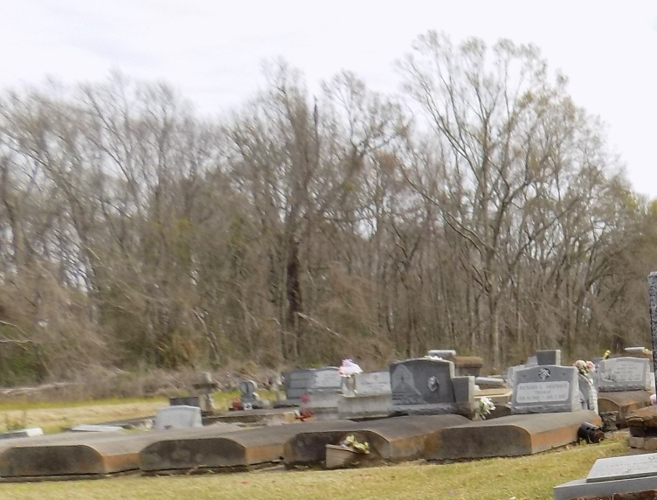

Jeffery Paul Accardo passed away on Friday, August 2, 2024 at the age of 57. He was born in Lutcher, LA and a resident of Covington, LA.
Beloved father of Mason Thomas Accardo (Brooke) and Blake Nicholas Accardo (Kymberly). Loving grandfather of Saylor Blake Accardo. Son of Judy Poincot Accardo and the late Jules Paul Accardo. Brother of Linda Accardo Falgoust (Paul) and Jerry Paul Accardo.
Relatives and friends are invited to attend the Visitation and Funeral Mass at St. Michael the Archangel Catholic Church, 6484 LA- 44, Convent, LA on Saturday, August 10, 2024. Visitation at church from 8:00 a.m. to 10:00 a.m. followed by a Funeral Mass at 10:00 a.m. Interment in St. Michael Church Cemetery, Convent, LA.

Rose Lynn Funeral Home, Lutcher, Louisiana
August 11, 2024

