Shawander Marie (Shelvin) Cantrelle
November 30, 1960 - March 11, 2025

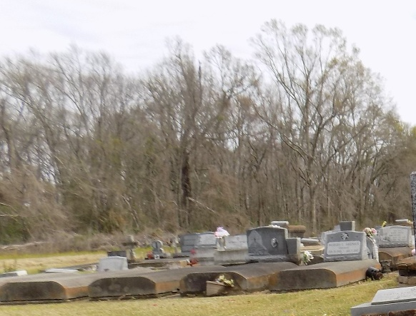

Shawander “Shawanda” Marie Shelvin-Cantrelle, affectionately known as Tee, T-Wanda, WowWee, and Sha passed away peacefully in her home on March 11, 2025. Born in Charity Hospital in New Orleans, LA, to Pearly Mae Williams Shelvin and IDell Shelvin.
She joined Celestine, the late Sandra, Tonya and her brothers, Carl and Alton, whom she deeply loved and cared for. Shawanda lived a life defined by love, kindness, and an unwavering dedication to caring for others. Shawanda was preceded in death by her husband, Clarence Daryl Cantrelle, whom she cared for devotedly in his final years. Also, awaiting her in heaven are her grandmother, Johana “Mama Joe” Williams, her grandfather, Pearly “Da” Williams, her great-grandmother, Emma “Mama Emma” Triche, her sister, Sandra Shelvin, her brother-in-law, Larry Martin, her father-in-law, Paul Cantrelle Jr., her mother-in-law, Shirley E. Cantrelle and brothers-in-law, K. Michael Cantrelle and Paul Cantrelle III.
Her heart was boundless, embracing all those she loved with a mother’s care. Her warmth and selfless spirit extended to her entire family—her mother, Pearly Mae Williams Shelvin, whom she cherished and lovingly looked after; her aunts, Zenata Williams-Pierre, Anna Shelvin Trim, Rosemary Shelvin Smith and Audrey Shelvin; her sisters and brothers, Celestine Shelvin Martin/JD, Tonya Farlough-Scott/Christopher, Carl Shelvin/Holly and Alton Shelvin/late Shirley, whom she deeply loved and cared for; her sisters and brothers-in-law, Janice Cantrelle-Kelson, Velma Adrienne Ferchaud, Christopher Cantrelle and Anthony Cantrelle; and step-children, Roudie Cantrelle, Katrina C. Albert and Anthony Cantrelle. She was a source of unwavering love and support to her nieces and nephews, LaCria Martin-Lee, Vinesha Shelvin, Carl Dennis, Kendra Shelvin, Alton Shelvin Jr. and John Scott; her great nieces and nephews, Brent York Jr., Breia York Turner and Legacy Lee; her great-great grand niece, Bella Turner; and her god-children, Dyrrhus Batiste and Journey McCray. Of course, she shared a special companionship with Simba, the dog her late husband so lovingly adopted for her as a parting gift—a loyal friend who never left her side, despite her lifelong fear of dogs. Among the many relationships she cherished, one held a unique and irreplaceable place in her heart—the bond she shared with her beloved niece, Skylar Reed-McMillon/James, who was her daughter in every way that mattered. Theirs was a relationship of unconditional love, devotion, and an unbreakable connection—one that will continue to transcend time and space.
A Celebration of live, love, and legacy will be held on Saturday, March 22, 2025 at Greater King Triumph Baptist Church, 2572 Lionel Washington St., Lutcher, LA 70071. Visitation is for 8am followed by the service for 10am. Entombment St. Michael Catholic Church Cemetery, 6484 LA-44, Convent, LA 70723.

Treasures of Life Funeral Services, Gramercy, Louisiana
March 21, 2025

