Adam Davis Hymel, Jr.
May 6, 1928 – May 7, 2025

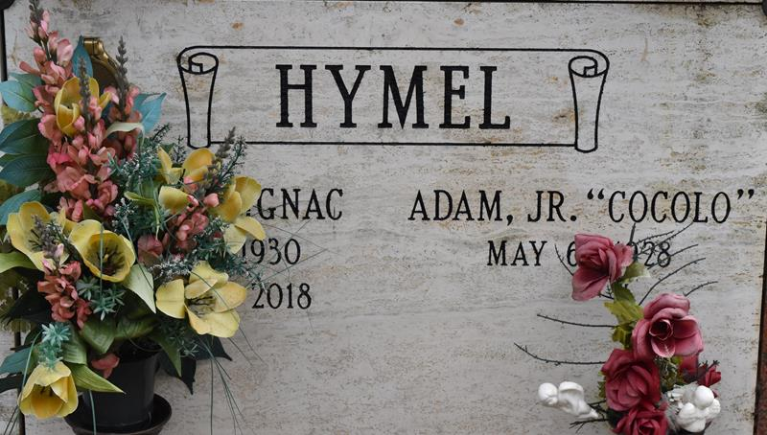

Adam (Cocolo) Davis Hymel, Jr. entered eternal life on May 7, 2025. Adam was born in Convent, LA. on May 6, 1928 to the late Adam Davis Hymel and Annette Ballot Hymel. He was preceded in death by his beloved wife of 67 years, Pearl Brignac Hymel and siblings Joyce, Chester, Richard and Hillard Hymel and Shirley Hymel Kinler.
Adam is survived by his children: Douglas Hymel, Jerry (Pamela) Hymel, Chester Hymel, Rhonda (Marco) Rios, Marlene (Mike) Yoes, Darlene (Bill) Marquis and Susan (Guy) Stillinger. He was a beloved grandfather to 10: Douglas (Tabitha) Hymel II, Dillon Hymel, Jeremy (Danielle) Hymel, Adam McEvoy, Nicole (Marc) McCloskey, Marc (Rachel) Rios, Michael (Autumn) Yoes Jr., Jared Yoes, Zain (Jessica) Stillinger, Andrew (Stevi) Stillinger; and great-grandfather to 14: Abby and Lilly Hymel, Isabella and Ryland Hymel, Grace and Olivia McCloskey, Naomi Rios, Mason Yoes, Ty, Jase and Mia Yoes, Riley Stillinger and Lyla and Luna Stillinger. Adam is also survived by his brother, Curtis Hymel and sisters-in-law, Dorothy Louviere and Esther Brignac, and a host of nieces, nephews, relatives and friends.
Adam was a veteran of the U.S. Navy. He retired from Shell Chemical Norco in 1988. He enjoyed fishing at his camp in Cocodrie, baseball, LSU and was an active participant in the American Legion for many years.
The family would like to thank Randy Bergeron and family for ministering the Holy Eucharist to Adam every Sunday.
He was a resident of Destrehan, LA for over 70 years. Relatives and friends are invited to attend visitation on Thursday, May 15th at St. Michael’s Catholic Church, Convent, LA from 9-11 am with mass and burial following.
In lieu of flowers, masses preferred at St. Charles Borromeo Catholic Church, Destrehan, La.

Rose Lynn Funeral Home, Lutcher, Louisiana
May 10, 2025

