Joseph Bruce LeBlanc
March 4, 1920 – January 21, 2002

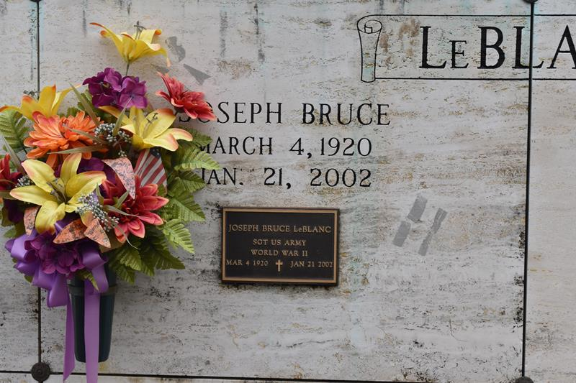

LEBLANC, Joseph Bruce "Nig" - A resident of Convent and a retired boilermaker, he died Monday, Jan 21, 2002, at St. James Hospital, Lutcher. He was 81 and a native of Sorrento. He was a U.S. Army veteran of World War II. He was a member of Union-Convent Volunteer Fire Department.
He was the beloved husband of Nelva Puccio LeBlanc; father of Darlene Schexnayder, Patty Sue Webre and the late Steve LeBlanc; grandfather of Danna Foster, Timothy Moody, Tricia Andrews and Darin Andrews; stepfather of Betty Brignac, Marie Keller and Sam Puccio Jr.; and stepgrandfather of Paula Marino, Oren Keller, Angela Macias, Mary Keller, Emily Carpenter, Steven Puccio, Charles Puccio, Christina Couvillion, Stacey Jara and Kathy Puccio. He is also survived by numerous great-grandchildren. He was the son of the late Olympe Villeneuve LeBlanc and Felicien LeBlanc; and brother of Thilda Walker, Audrey Painter, Ruby LeBlanc, Aris Trabeaux, Emmaline LeBlanc, Elwood LeBlanc and the late Beatrice Schexnayder and John LeBlanc.
Pallbearers will be Troy Schexnayder, Paul Kerek, Clay Schexnayder, Glenn Lee, Sam Marino Jr., Oren Keller and Steven and Charles Puccio. Honorary pallbearers and Elwood LeBlanc, Gilroy Huguet, Sam Puccio Jr. and Paul Keller.
Friends may call at Ourso Funeral Home, Airline Highway, Gonzales, from 5 p.m. to 9 p.m. Tuesday and from 9 a.m. to 10:15 a.m. Wednesday. Relatives and friends of the family are invited to attend the funeral services. Mass of Christian Burial will be celebrated at St. Michael's Catholic Church, River Road, Convent, at 11 a.m. Wednesday, celebrated by the Rev. Mario Rizzuto. Interment in St. Michael's Catholic Cemetery.

The Advocate, Baton Rouge, Louisiana
January 23, 2002
**

LeBLANC CONVENT – Joseph Bruce LeBlanc, 81, a native of Sorrento and resident of Convent, died Jan. 21. He was the husband of Nelva Puccio LeBlanc; father of Darlene Schexnayder, Patty Sue Webre and the late Steve LeBlanc; and stepfather of Betty Brignac, Marie Keller and Sam Puccio Jr. He was the brother of Thilda Walker, Audrey Painter, Ruby LeBlanc, Arys Trabeau, Ruby, Emmaline and Elwood LeBlanc and the late Beatrice Schexnayder and John LeBlanc. He is also survived by four grandchildren, 10 stepgrandchildren and numerous great-grandchildren. He was a retired boilermaker, U.S. Army veteran of World War II and a member of the Union/Convent Volunteer Fire Department. Services are today at 11 a.m. at St. Michael the Archangel Catholic Church, Convent, with interment at the church cemetery. Visitation starts at 9 a.m.

L’Observateur, LaPlace, Louisiana
Thursday, January 24, 2002

