Johnnie Kay (Channell) Melancon
February 16, 1982 – March 12, 2025

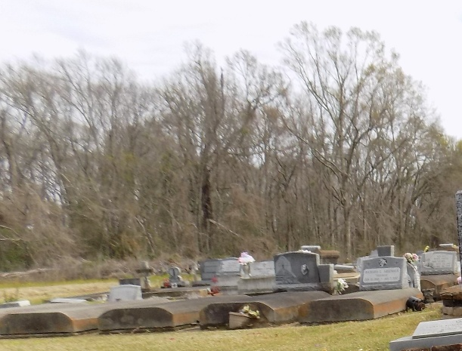

Johnnie “KK” Kaye Channell Melancon passed away on Wednesday, March 12, 2025 at the age of 43.
Beloved wife of Bruce Melancon for 14 years. Mother of Chris Ansley, Logan Ansley. Step- Mother of Tyler Melancon and Kaysi Wilson. Grandmother of Harper. Step-Grandmother of Everett and Wren Melancon and Kayden Washington. Daughter of John Channell and the late Mary Chandler. Sister of Tisha Liechti, Karey Johnson, Bobbie Jo Nicholason and the late Christie Eckhardt.
Johnnie always had a smile on her face, even while fighting cancer. Doctors originally gave her 6-9 months to live, however she blessed her family and friends with 2 more years of her life. She never needed an excuse to go fishing. If she wasn't fishing she was probably either making wood burning art, kayaking, or drawing designs, for her latest hobby of tattooing. She loved her family and friends more than anything.
Relatives and friends are invited to attend a Word of Remembrance service on Saturday, May 3rd, 2025, at the St. Michael’s Hall in Convent, beginning at 1:00 p.m. Burial will immediately follow at St. Michael’s Catholic Cemetery.

Rose Lynn Funeral Home, Lutcher, Louisiana
March 15, 2025

