Madeline (Woodfork) Woodland
October 7, 1938 – January 5, 2025

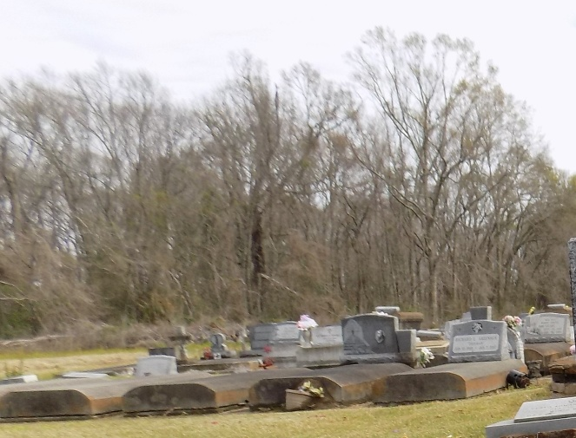

Madeline was born on October 7, 1938 to Norbert Ferdinand and Regina Duplessis Woodfork in Convent, LA. She is the fifth of eight children. She attended Cypress Grove High School with the class of 1958 in Lutcher, LA and later obtained her GED on May 10, 1996 from the Louisiana State Department of Education. On August 9, 1958 she married Henry Woodland. To this union three children were born: Cynthia, Regina, and Jerome.
On Sunday, January 5, 2025 by the providential hands of Almighty God, Madeline, at the blessed age of 86, was welcomed into her heavenly home at Our Lady of the Lake Regional Medical Center in Baton Rouge, LA. Madeline was a hard-working woman. Some of her jobs included working at Colonial Sugar Refinery from 1970 – 1979, at Walmart in 1997, and a loving caregiver for a special needs person in 1998. After raising her three children, she continued to spread her love by helping to care for her grandchildren and great-grandchildren.
Madeline (“Cecelia”) had a smile that could brighten the darkest days, a laugh that was contagious, and a zeal for life that is unmatched. It was always on display in her love for gardening, traveling, fishing, dancing, singing (mostly off key), spending time with family in and out of state, attending sporting events with three generations of children, attending school events such as grandparent’s day, and we dare not forget about her love of cooking and delight in eating. Some of her most cherished moments include attending her grandchildren’s basketball, football, baseball and soccer games, travels to Disney World, fishing trips, taking family cruises, attending Carnival, St. Patrick’s Day and Christmas parades. Numerous trips were taken with Thibodaux Express (Cayden’s AAU basketball team), eating breakfast with Jerzee at “EWC Grits with Grands” at Emily C. Watkins Elementary, and the surprise visit to her son on his 56th birthday in Minnesota.
Cherished memories will always be in the hearts of Madeline’s three children, Cynthia Joseph, Regina Woodland Johnson (James), and Jerome Woodland, Sr; two sisters, Diane Woodfork Fredricks of San Leandro, CA, and Ursula Woodfork Lyons (Jerome, Sr.) of Port St. Lucie, FL; four grandchildren, Courtney Joseph-Francois (Donnie, Sr.), Jerome Woodland, Jr. (Shameka Edwards), Andre Henry, and Andrea Henry; eleven great- grandchildren, Covay Joseph, Coy Joseph, Cayden Francois, Donnie Francois, Jr., Jewel Woodland, Christian Ceasar, Jream Woodland, Jerzee Woodland, Javon Henry- Varmall, Rainn Knightshed, and Remmi Knightshed; four sister- in-laws and one brother-in-law, Darlene Watson, Lillie Mae Woodland, Audrey Woodland, and Larry Woodland (Cassandra); one daughter-in-law, Lisa Thomas; four godchildren, Jacinta Braud, Consuelo Duplessis, Mark Tureaud and JaVon Butler; and a host of other relatives and friends.
Madeline was preceded in death by her parents, the late Regina and Norbert Ferdinand Woodfork, Sr.; four sisters, Inez Woodfork, Naomi Woodfork Raphael, Joyce Woodfork Dusuau, Yvonne Woodfork Johnson; one brother, Norbert Ferdinand Woodfork, Jr.
A public gathering of friends and family will be held on Monday, January 13, 2025 from 5:00 - 7:00 pm at Treasures of Life Funeral Services, 315 E. Airline Hwy., Gramercy, La 70052. A Mass of Christian Burial will follow on Tuesday, January 14, 2025 at St. Joseph Catholic Church, 2130 Rectory St., Paulina, La 70763. Visitation begins for 9:00am followed by Mass for 11:00am. Father Vincent Dufresne, celebrant. Interment St. Michael Catholic Church Cemetery, 6484 La-44, Convent, La 70723.

Treasures of Life Funeral Services, Gramercy, Louisiana
January 19, 2025

