Rebecca Alexis-Ellis
April 16, 1917 – February 22, 2009

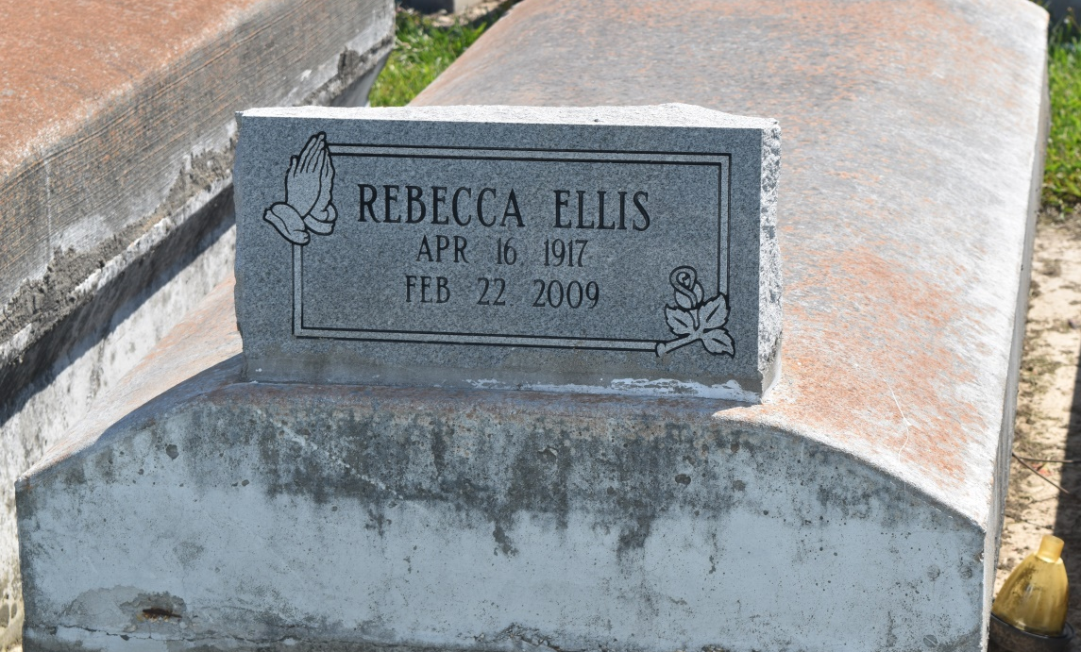

Rebecca Alexis-Ellis departed this earthly life and entered into eternal rest on Saturday, February 21, 2009 at Riverland Health Care Center, Lutcher, LA. Wife of the late George Alexis, Sr. by 1st marriage and the late Leon Ellis by second marriage. Beloved mother of Donell Alexis of Houston,TX, Freddie Mae Jones of Inglewood, CA, Fredrick Alexis of Mt. Airy, LA, Gloria Brown of Lutcher, LA, the late George Jr. and Calvin Alexis. Stepmother of Hilton Leonard of LaPlace, LA and Addison Ellis of Highland, CA. Mother-in-law of Audrey Alexis of LaPlace, LA, the late James Jones, Alton Brown, Geraldine Alexis and Mary Alexis. Sister of Hilary Patterson of Lynwood, CA and Lillian Carter of Convent, LA. Also survived by 21 grandchildren, 44 great-grandchildren, 18 great-great-grandchildren, a host of nieces, nephews, other relatives and friends. A native of Convent, LA and a resident of Reserve, LA. Age 91 years.
Relatives and friends of the family, also pastors, officers and the members of the Zion Travelers Baptist Church and all neighboring churches are invited to attend the Funeral Service on Saturday, February 28, 2009 at 11:00 a.m. at Zion Travelers Baptist Church, 713 Walnut St., LaPlace, LA. Rev. Isiah Franklin, officiating. Interment in Zion Travelers Cemetery, Reserve, LA. Visitation will be from 9:00 a.m. until 11:00 a.m. at the above named Church.
BARDELL'S MORTUARY of Mt. Airy, LA in charge. Information: (985) 5356837.

Times-Picayune, The (New Orleans, LA) - Friday, February 27, 2009
Contributed by Jane Edson

