Charlene S. Anderson
- January 5, 2013

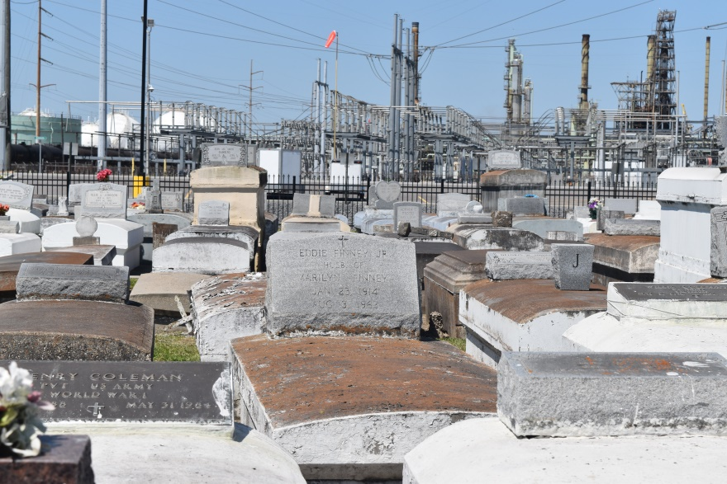

Charlene S. Anderson departed this life on Saturday, January 5, 2013.
She leaves to cherish her memory her beloved husband Russell Anderson Jr. Children: Jessie, Terrell, Kenon and Tameria Hutchinson. Also survived other relatives and friends.
Funeral Service will be held on Saturday, January 12, 2013 at 11:00am at the Beech Grove B.C., Reserve, LA. Viewing from 10:00am until service time.
Internment in Zion Travelers Cemetery, Reserve, LA. Rev Wesley Anderson Sr., Pastor. Rev Jeffery Patterson, officiating.
Service Entrusted To Hobson Brown Funeral Home, Garyville, La.
Published in The Times-Picayune from January 10 to January 11, 2013.

