Anny Belle (Foster) Banks
November 4, 1943 – May 31, 2003

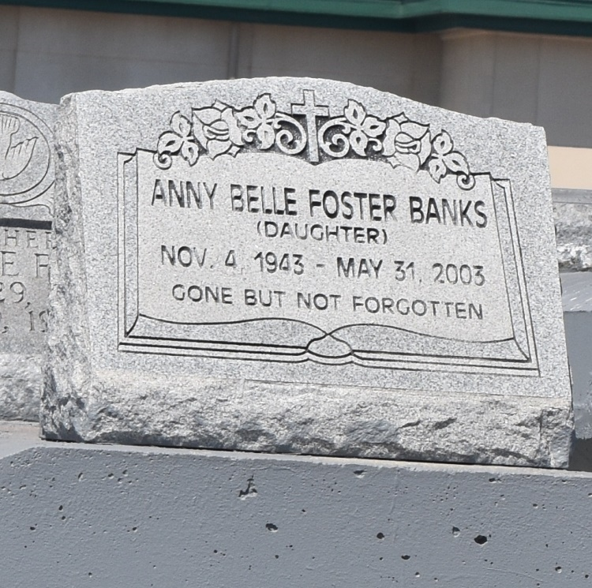

Anny Belle Foster Banks, a homemaker, died May 31 of heart failure at River Parishes Hospital. She was 59. Mrs. Banks was a lifelong resident of Mount Airy. She served as an usher for 30 years at St. John Baptist Church in Mount Airy. Survivors include her husband, Louis Banks; her daughter, Stacie Banks; a sister, Earline Sparks of Vacherie; and three grandchildren. A funeral will be held today at 11 a.m. at St. John Baptist Church in Mount Airy. Visitation will be at 10 a.m. Burial will be in Zion Travelers Cemetery in Lions, La. Hobson Brown Funeral Home is in charge of arrangements.

Times-Picayune, The (New Orleans, LA) - Saturday, June 7, 2003
Contributed by Jane Edson

