Herbert Richard Banks
June 2, 1941 – February 5, 2007

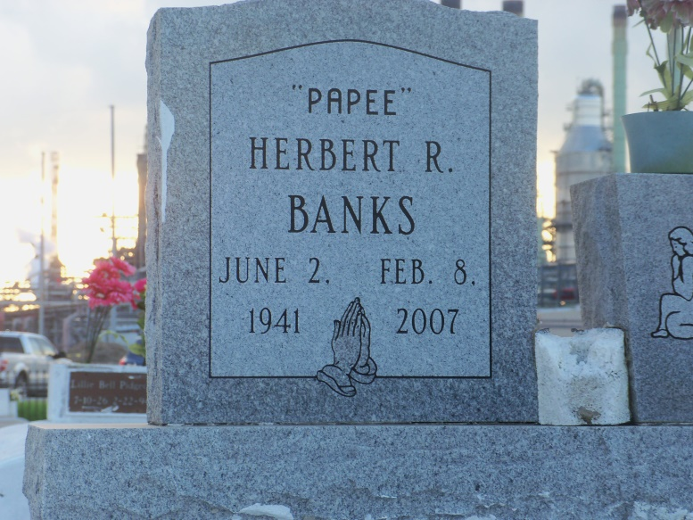
Photo by GeniHound

Herbert (Papee) Banks, of Lutcher, LA at River Parishes Hospital, on Thursday, February 8, 2007. Son of the late Lillie Bell Pidgeon and Lamus Banks. Stepson of Robert Pidgeon, Sr. Husband of Elizabeth Banks of Lutcher, LA. Father of Karen Randall of Baton Rouge, LA, Raymond (Sherri) Carter, Bruce (Delhine) Carter of Austin, TX and LaDarrion Banks of Lutcher, LA. Stepfather of Joseph McKinley of Lutcher, LA, Charley, Michael, Henry and Herbert Carter of Garyville, LA and Mattie Smith of Austin, TX. Brother of Rosemary Hardy (Richard) of LaPlace, LA, Joyce Johnson of Garyville, LA, Mary Ann Branck (Joyce) of LaPlace, LA, Barbara Bynum of Baton Rouge, LA, Roger Johnson of Garyville, LA and Roy Pidgeon (Carolyn) of Garyville, LA, the late Sharon, Robert, Kevin and Nathaniel Pidgeon. Godfather of Lisa Anderson and Candace Turley. Nephew of Charlotte Anderson. Also survived by a host of grandchildren, nieces, nephews, sisters- and brothers-in-law, other relatives and friends. A native of Garyville, LA and a resident of Lutcher, LA. He was employed by St. John Baptist Parish Water Works.
Relatives and friends of the family; also pastors, officers and members of Israelite B.C., Providence B.C. #1, True Light B.C., St. John B.C., King Solomon, First Community Antioch and neighboring churches are invited to attend the Funeral Services on Monday, February 12, 2007 at 11:00 a.m. from the Isralite B.C., Lutcher, LA. Rev. Kevin Frederick, officiating. Interment Zion Travelers Cemetery, Reserve, LA. Visitation at the church after 9:00 a.m.
Arrangements by THE BALONEY FUNERAL HOME, L.L.C., 399 Earl Baloney Dr., Garyville, LA, 70081; Information: (985) 535-2540

Times-Picayune, The (New Orleans, LA) - Sunday, February 11, 2007
Contributed by Jane Edson

