Gertie (Jackson) Bernard
January 1, 1919 – Jun 13, 2003

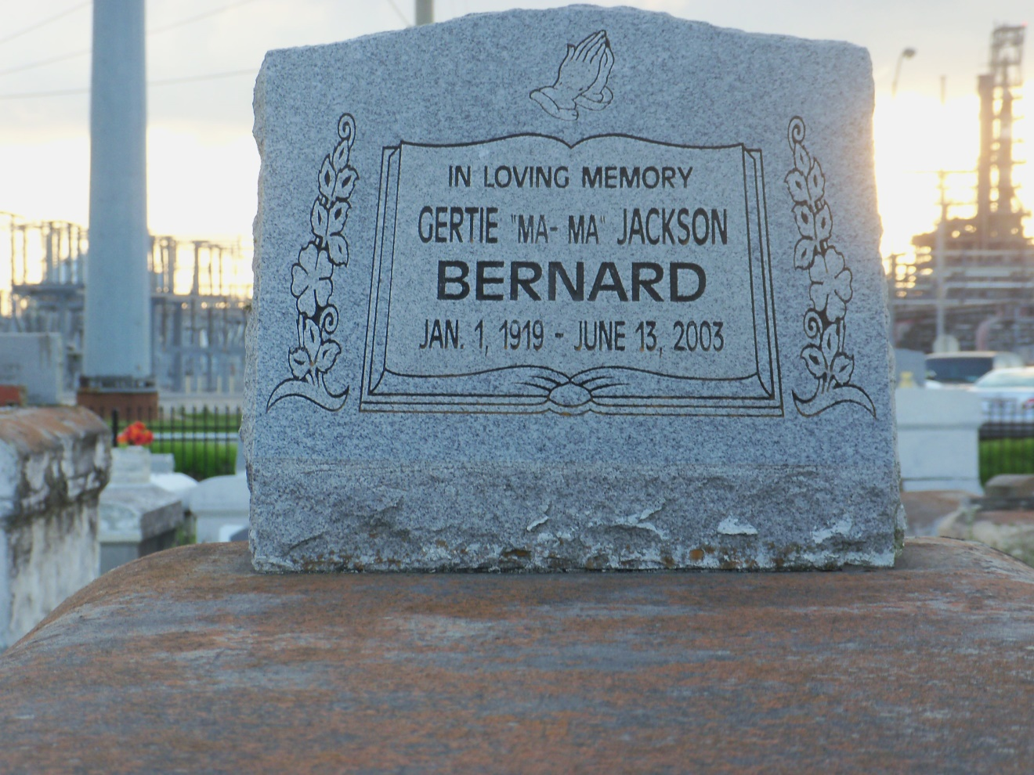
Photo by GeniHound

Gertie "Ma-Ma" Jackson Bernard, a homemaker, died June 13 of natural causes at her home. She was 84. Mrs. Bernard was born in Lemonville and lived in Reserve. Survivors include four sons, James Bernard Sr. of Baton Rouge, Lawrence Bernard Sr., Albert Bernard Sr. of Garyville and Alvin Bernard; six daughters, Gertie Bernard of New Orleans, Helen Bernard of Garyville, Audrey Augusta of Donaldsonville, Clara Robertson, Gwendolyn Bernard and Cynthia Waite of LaPlace; 24 grandchildren; 30 great-grandchildren; and seven great-great-grandchildren.Visitation will be held today from 5:30 to 7:30 p.m. at Hobson Brown Funeral Home, 134 Daisy St. in Garyville. A funeral will be held Saturday at 11 a.m. at Zion Travelers Baptist Church on West 23rd Street in Reserve. Burial will be in the church cemetery.

Times-Picayune, The (New Orleans, LA) - Friday, June 20, 2003
Contributed by Jane Edson

