Helen Marie Bernard
March 11, 1940 – August 25, 2003

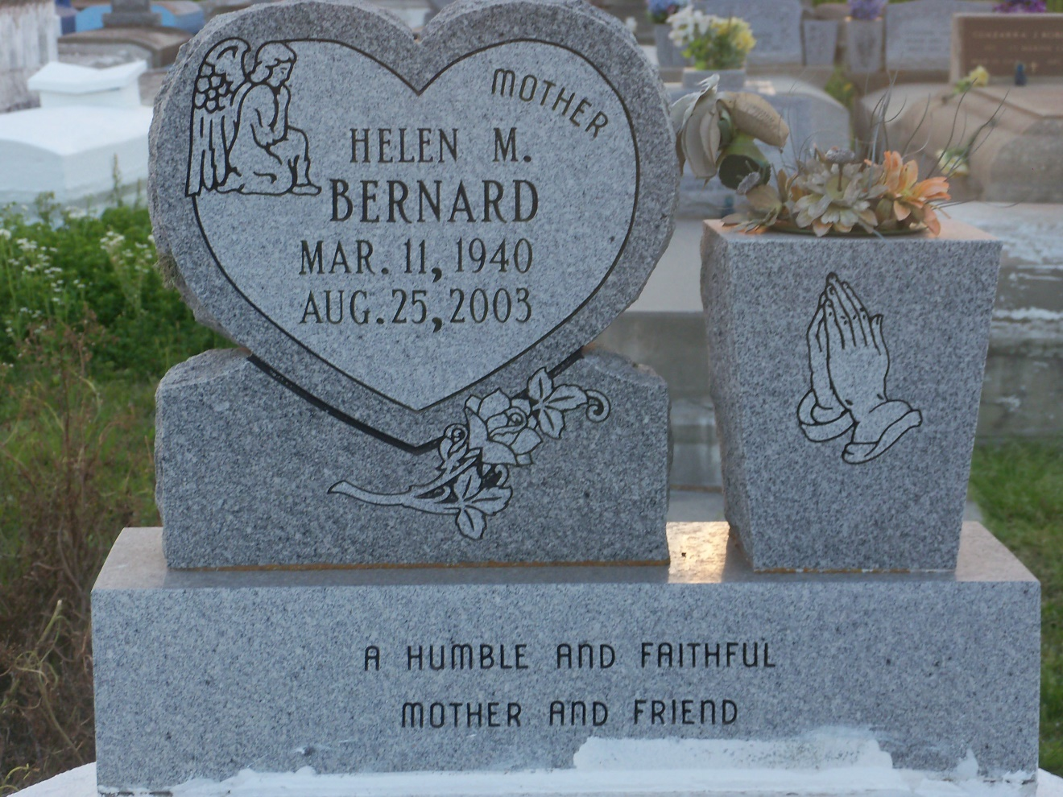
Photo by GeniHound

Helen Marie Bernard, a retired lunchroom technician, died Monday of kidney failure at Kenner Regional Hospital. She was 63. Ms. Bernard was born in New Orleans and lived in Garyville. She was a graduate of Fifth Ward High School in Reserve. She was a deaconess at Zion Travelers Baptist Church, an honorary member of Friendly Club of Gramercy and a member of the Citizens United for Progress in St. John. Survivors include a son, Gregory Bernard of Garyville; four daughters, Joyce B. Duhe, Leasure and Gayle Bernard, and Murial Cook; five sisters, Gertie M. Bernard, Audrey Augusta, Clara Robertson, Gwendolyn Bernard and Cynthia Waite; six grandchildren; and two great-grandchildren. A funeral will be held Saturday at 11 a.m. at Zion Travelers Baptist Church in Reserve. Visitation will be held today from 5:30 to 7:30 p.m. at Hobson Brown Funeral Home, 134 Daisy in Garyville, and on Saturday at 10 a.m. the church. Burial will be in the church cemetery.

Times-Picayune, The (New Orleans, LA) - Friday, August 29, 2003
Contributed by Jane Edson

