Viola M. Blue
May 30, 1929 – March 3, 2011

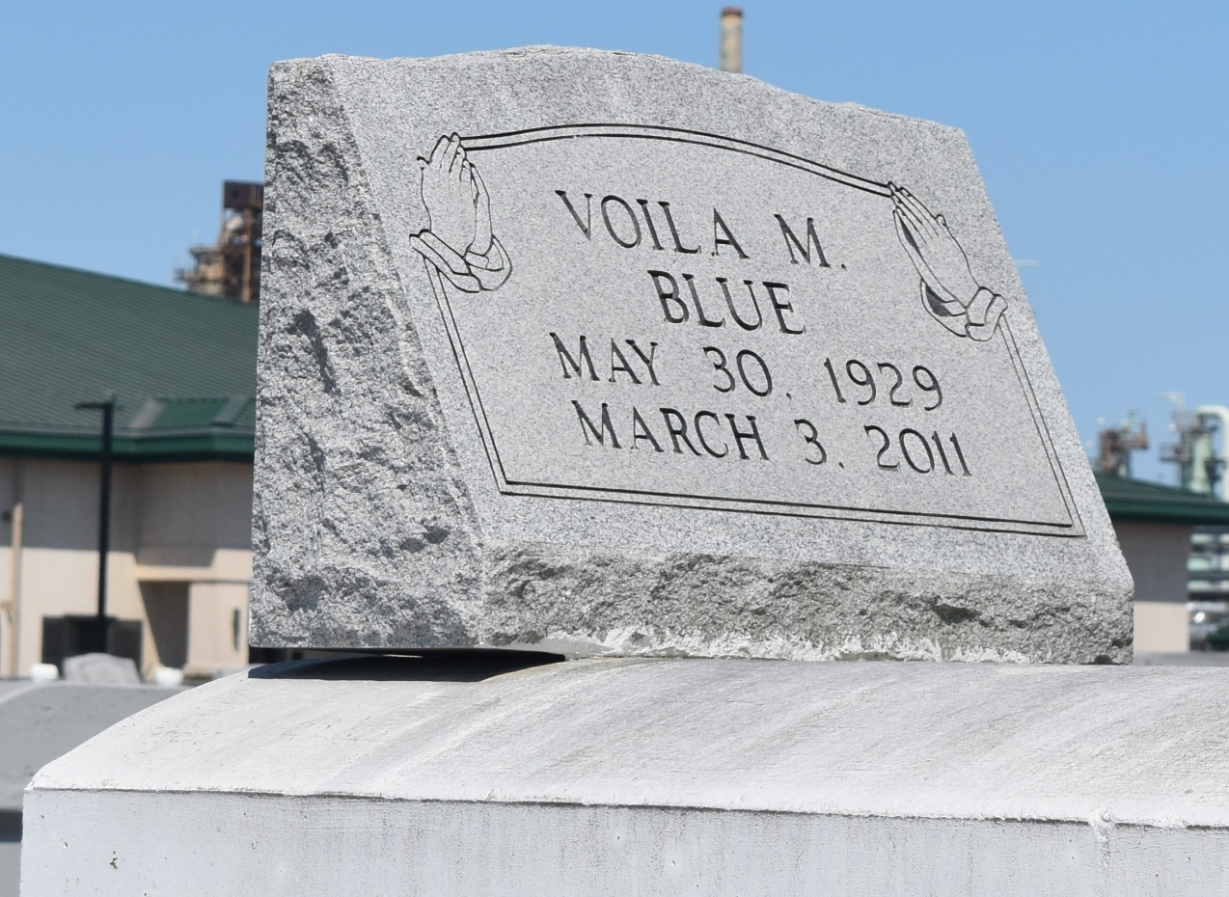

Viola "Kutt" M. Blue, domestic cleaner, died March 3, 2011 at River Region Hospice, at the age of 82. Resident of Garyville, La. She is the foster mother of Lori (Elton) Wiltz. Survived by two god-children, a host of cousins and friends.
Relatives and friends are invited to attend the Funeral Service on Thursday, March 10, 2011 at 10:00am at St. Mark Baptist Church, 132 Marquez St., Mt Airy, La. Pastor Oscar R. Nelson officiating. Visitation will begin at 8:00 am until 10:00 am. Burial will be held at the Zion Travel Cemetery, Reserve, La. Arrangements by Rhodes United Fidelity Home Inc., 2929 Scenic Hwy., Baton Rouge, La.

Times-Picayune, The (New Orleans, LA) - Wednesday, March 9, 2011
Contributed by Jane Edson

