Percy Bolden Sr.
June 15, 1935 – January 12, 2001

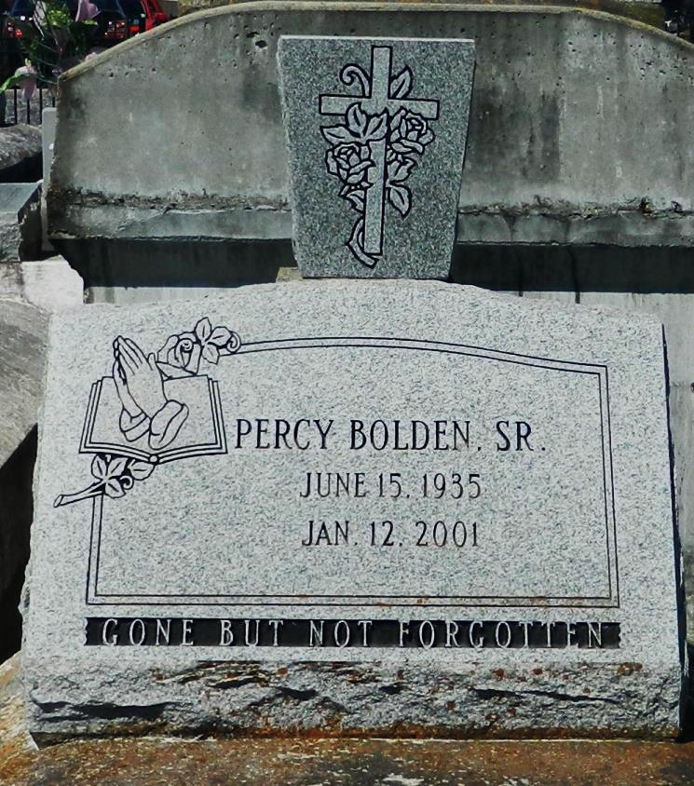

Percy Bolden Sr., a retired laborer, died Friday of complications from a brain tumor at River Parishes Hospital in LaPlace. He was 65. Mr. Bolden was a lifelong resident of Garyville. He was an employee of the San Francisco Sugar Mill for 25 years and worked at the San Francisco Plantation House for 16 years before retiring. Survivors include his wife, Joyce W. Bolden; four daughters, Christine Penn, Mary Staggers, Vanessa Preston and Angela Bolden; four sons, Michael Bolden, Percy Bolden Jr., Bruce Bolden and Ronaldo Bolden Sr.; a stepson, Nathan Williams; three sisters, Augustine Tuco, Georgina Brown and Emelda Walker; three brothers, Emile Bolden Jr., August Bolden and Charles Bolden; 23 grandchildren; and 14 great-grandchildren. The funeral will be held today at 11 a.m. at St. John the Baptist Church in Mount Airy. Visitation will begin at 9 a.m. Burial will be in Zion Travelers Cemetery in Lions. Hobson Brown Funeral Home is in charge of arrangements.

Times-Picayune, The (New Orleans, LA) - Wednesday, January 17, 2001
Contributed by Jane Edson

