Rose Mary (Washington) Bolden
October 12, 1949 – June 22, 2001

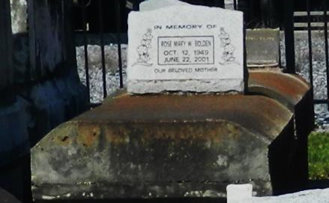

Rose Mary Washington Bolden departed this life on Friday, June 22, 2001 at her home Reserve, LA. Daughter of James Washington and Mary Ellis. Wife of Percy Bolden, Jr. Mother of Allen Holland, Jr., Sarah Holland. Sister of Edward Craighead., Harold, Allen, Larry and Jeffery Washington, Glendora Warren and Brenda Lumar. Two grandchildren and a host of nieces, nephews, other relatives, a resident of Reserve, LA. Age 50 years. Sister and Brother-in-laws.
Friends and family, pastors, officers and members of True Light Baptist Church and all neighboring churches are invited to attend the funeral on Wednesday, June 27, 2001 from the above named church at 11:00 a.m. Little Hope St., Garyville, LA. Rev. Wesely Anderson, Sr., Pastor. Interment in Zion Travelers Cemetery, Lions, LA. HOBSON BROWN FUNERAL HOME in charge of arrangements. Viewing will begin at 10:00 a.m. until funeral time.

Times-Picayune, The (New Orleans, LA) - Wednesday, June 27, 2001
Contributed by Jane Edson

