Freddie Braxton Sr.
February 13, 1947 – February 19, 2016

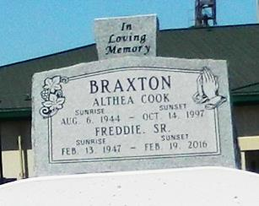

Freddie Braxton Sr, departed the life on Friday, February 19, 2016, age 69. Father of Rosalind Cook-Patterson and Freddie Braxton Jr. Also survived a host of other relatives and friends.

Funeral service will be held on Friday, February 26, 2016 at 10:00am at Greater New Plymouth Rock B. C., 110 NW 13th St Reserve, LA 70084. Rev. David Carter, Pastor Officiating. Internment in Zion Travelers Cemetery, Reserve, LA. Visitation from 8:00am until service time ONLY.

Service Entrusted to Hobson Brown Funeral Home Garyville, La 70051 985-535-2516

Times-Picayune, The (New Orleans, LA) - Tuesday, February 23, 2016
Contributed by Jane Edson

