Rosalie Braxton
June 18, 1953 – December 31, 2011

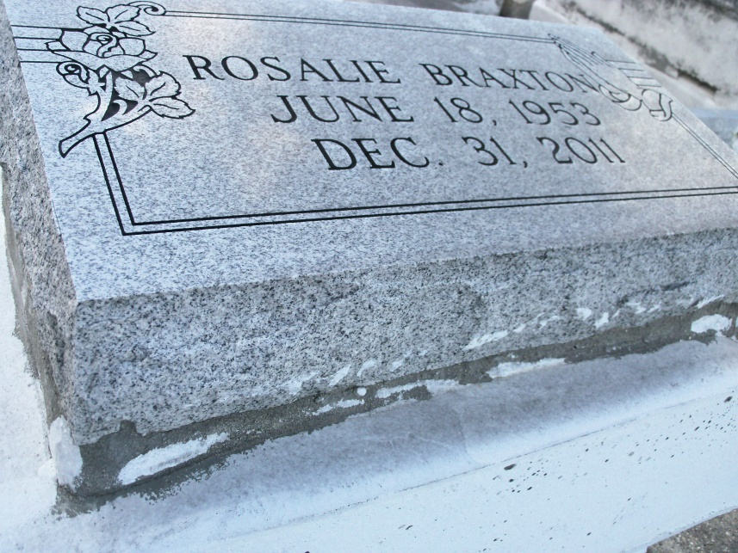
Photo by GeniHound

Rosalie (To-To) Braxton, age 58, a native of Garyville, La., departed this life on Saturday December 31, 2011 in Dallas TX. Daughter of the late George Braxton and Rosalie Brown Bolden and stepdaughter of Vivian Braxton and the late Norliss Bolden. Mother and mother-in-law of Denise Singleton Ranton (Derrick), Herbert and Andrea Singleton and Lynell and Hollis Braxton, Sister and sister-in-law of Elizabeth (Ma-Me) (Bobby) Taylor, Lizzie Mae (Allen) Washington, Hobson Bolden, and Lynette (late Mark) Mitchell, Georgia Ann (Timothy) Fobb, Judy (James) Robinson, Virgie Watkins, Shelia Buyard, Bobby and George Braxton, (Lorraine), Horace (Emma) Morris, the late Hilton Morris, Linda Esko and Tim Braxton. Niece of Albert (Red Bill) and the late Lizzie Mae Brown Burl. Also survived by ten grandchildren, three great-grandchildren, a host of nieces, nephews, cousins, and friends. Granddaughter of the late Hobson and Rosie Zeno Brown, Danny and Sarah Braxton.
Pastor, Officers, and members of Milesville Memorial Church of God in Christ, New Light B.C. of Dallas, Texas, St. John B.C., and all neighboring churches, employees of Cargill, and St. John Parishes School Board are invited to attend the Funeral Services on Saturday, January 7, 2012 at 11:00 a.m. at Greater New Mt. Zion B.C. Hosting Church Rev. Wesley Anderson Jr., Pastor, Bishop Ronald Frank, Officiating. Interment in Zion Travelers Cemetery, Reserve, La., Visitation from 9:00 a.m. until service time (only).
Service Entrusted to Hobson Brown Funeral Home, 134 Daisy St., Garyville, La. 70051,
(985) 535-2516

Times-Picayune, The (New Orleans, LA) - Friday, January 6, 2012
Contributed by Jane Edson

