Audrey Mae Breaux
June 7, 1938 – April 12, 2011

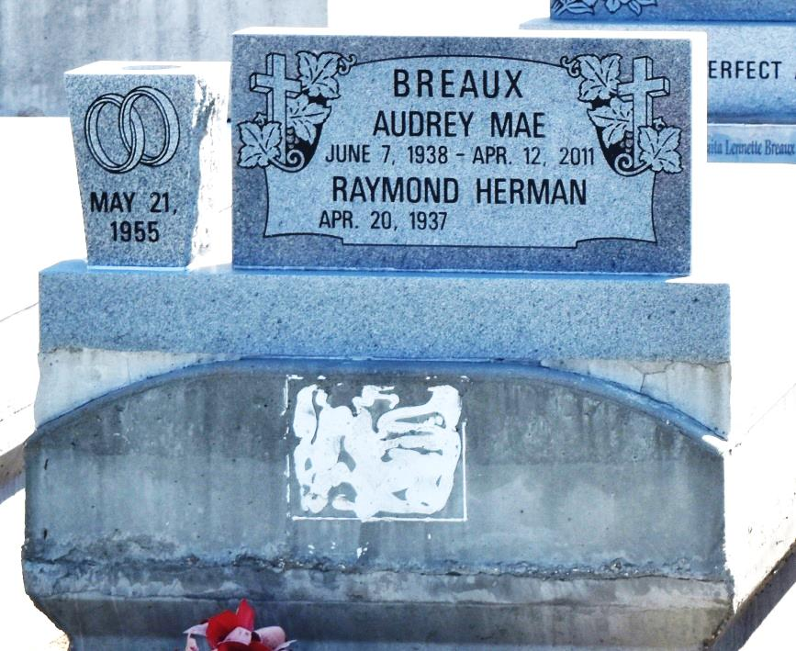

Audrey (Sugar MA) Breaux, age 72, departed this life on Tuesday, April 12, 2010 in LaPlace, La. Wife of Raymond Breaux, Sr. Mother of Pamela Brown, Lisa Adam, Donna London, Senerca Frederick, Erika Wilson, Raymond Jr., Ray, Elton, Michael, Christopher, Kendall, Alejandro Breaux. Also survived by 30 grandchildren, 16 great-grandchildren, 1 brother 1 sister, sons- and daughters-in-law, and a host of nieces, nephews, cousins and friends. A native and a resident of Garyville La.
Visitation and Services will be on Saturday April 23, 2011 at Beech Grove B.C., 117 Beech Grove Dr., Reserve, La., at 11:00 a.m. Rev. Wesley Anderson, Sr., Pastor - Officiating. Visitation at the church from 10:00 a.m. until service time. Interment in Zion Travelers Cemetery Reserve, La., all neighboring churches are invited to attend.
Professional Service Entrusted to Hobson Brown Funeral Home, Garyville, La 70051, (985) 535-2516

Times-Picayune, The (New Orleans, LA) - Friday, April 22, 2011
Contributed by Jane Edson

