Raymond Herman Breaux, Sr.
April 20, 1937 – May 27, 2018

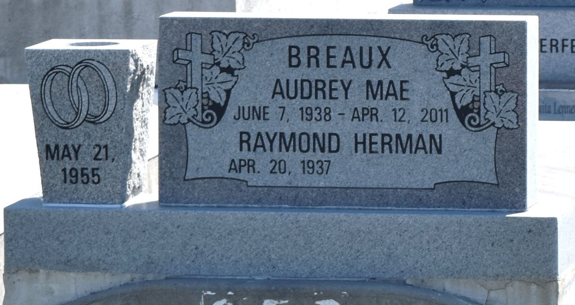

Raymond "Ray Ray" Breaux, Sr. departed this life on Sunday, May 27, 2018. Husband of the late Audrey "Sugar Ma" Breaux, Mother of Pamela Brown, Lisa Adam, Donna London, Erika Wilson, Seneca, Ray, Elton, Michael, Christopher, Kendall and Alejandro Breaux. Raymond is survived by his (1) brother, (2) sister and a host of grandchildren, great grandchildren, nieces, nephews, other relatives and friends. Celebration Service will be on Saturday, June 09, 2018 at Beech Grove B.C. 117 Beech Grove Dr. Reserve LA, at 11:00 am. Visitation at 10:00 am. Pastor Cory Batiste Officiating. Interment in Zion Traveler Cemetery, Reserve LA. Professional Services entrusted to the caring staff Hobson Brown Funeral Home, 134 Daisy St., Garyville, LA 70051, (985) 535-2516.
Downloaded from Legacy.com on 6/19/2018

