Gertrude Bright
December 8, 1927 – April 3, 2008

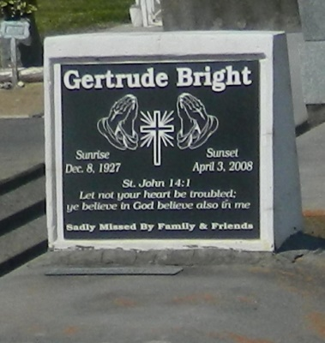

Gertrude Bright, a Homemaker, age 80, passed away on Thursday, April 3, 2008 in Metairie, La. Daughter of the late Abraham Prembrook and Emma Taylor Raphile. Wife of the late Victor Bright, Sr. Mother of Sylvia James, Ulysses and Geraldine Bright, and the late Victor Bright, Jr. and Shirley P. Woodland. Sister of Josephine Jackson and Delores Ward. Also survived by a host of grandchildren, great-grandchildren, nieces, nephews, daughter, sons, and sister in law, cousins, other relatives and friends. A native of Gramercy and a resident of Reserve, La.
Pastor, Officers and members of Greater New Plymouth Rock B.C. and all neighboring churches are invited to attend the Funeral Service on Saturday, April 12, 2008 at 11:00a.m. from the above named church, 110 N.W. 13th St., Reserve, La. Rev. David Carter, Pastor Officiating. Interment in Zion Travelers Cem., Reserve, La. Visitation at the Church from 9:00a.m. until Service time.
Service Entrusted to Hobson Brown Funeral Home, Garyville, La.

Times-Picayune, The (New Orleans, LA) - Friday, April 11, 2008
Contributed by Jane Edson

