Reverend Harold L. Brown
Abt. 1936 - October 17, 2020

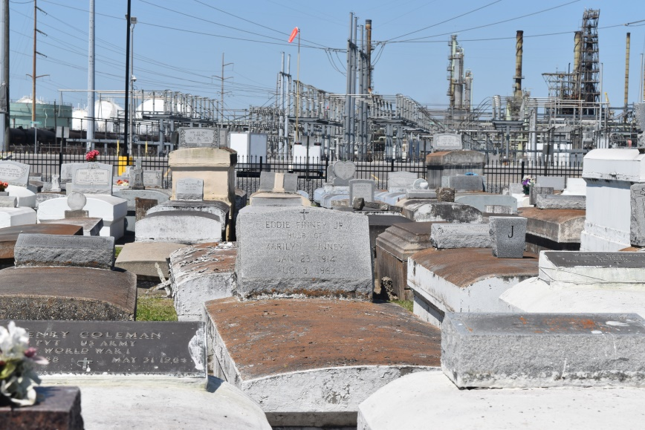

Reverend Harold L. Brown peacefully passed away on Saturday, October 17, 2020. Son of the late Edward and Geneva Brown, husband of the late Yvonne Ellis Brown, father of Harold Jr, Charlene, Kenneth Sr., (Yolanda), Shawn, Tremaine Brown Sr., and the late minister Avis Brown, brother of Rosalie Lennix, Beatrice Hall, Adam Leroy Shelton, Lilton, Edward Brown Jr, and the late Earl Brown. Harold is also survived by 20 grandchildren, 31 great-grandchildren, 3 great-great grandchildren and a host of nieces, nephews, cousins and friends. Age 84. Funeral Service on Saturday, October 24, 2020 at Greater New Mt. Zion B.C., Historic East St., Garyville, La at 11:00 a.m., Reverend Wesley Anderson, Jr., Pastor. Visitation at 9 a.m. until service time. Interment in Zion Travelers Cemetery. Due to CDC (Covid 19) restrictions, seating is limited. Masks and social distancing are required. Professional services entrusted to the caring staff of Hobson Brown Funeral Home, 134 Daisy St., Garyville, La. 70051, 985-535-2516.

Published in The Times-Picayune (New Orleans, LA) from Oct. 22 to Oct. 24, 2020.

