Patricia Ann Brown
June 18, 1947 – June 24, 2005

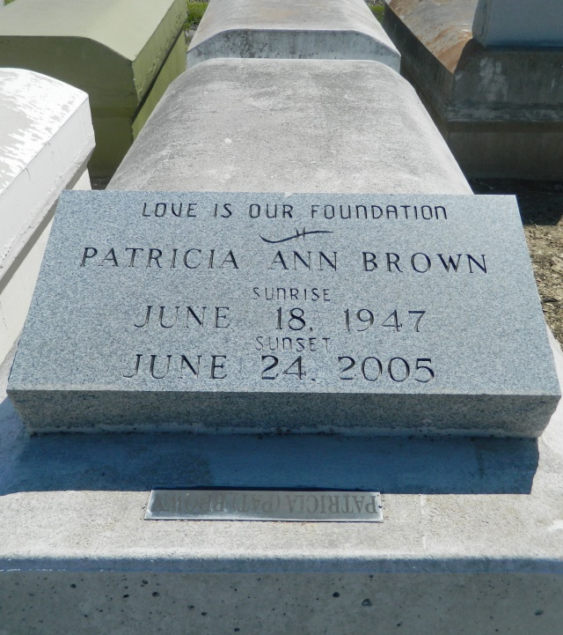

RESERVE - Patricia "Pat" Brown, 58, a native and resident of Reserve, died June 24.
She is survived by her children Bryon, Andrew, Gerald, Orlando, Michael and Thurmas (Dolla) Brown, Lizelle Bradley, Marilyn McGuffy, MaGary Moore, Henry Ann, Paula Valinteen and Ingrid Brown.
She is also survived by 27 grandchildren and six great-grandchildren.
Services will be held today at 11 a.m. at the Tchoupitoulas Chapel, Reserve, with interment in the Zion Travelers Cemetery, Reserve.
Hobson Brown Funeral Home of Garyville is in charge of arrangements. Visitation at the church begins 10 a.m.

L'Observateur (La Place, LA) - Thursday, June 30, 2005
Contributed by Jane Edson

