Alan Burl Sr.
November 24, 1956 – December 25, 2000

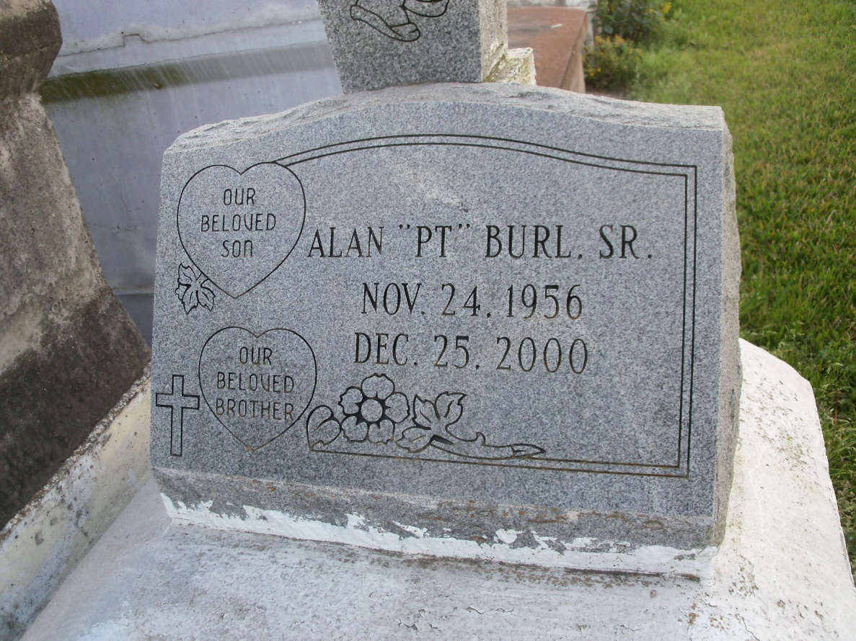
Photo by GeniHound

GARYVILLE - Alan "PT" Burl Sr., 44, a native and resident of Garyville, died Dec. 25. He was the father of Roneika Butler and Alan Jr. and Ewlynn Burl. He was also the son of Albert Burl Sr. and the late Lizzie Mae Brown Burl and brother of Linda Johnson, Lilac Rixner, Rainere London, Cherry Frank, Albert Burl and the late Mona Lisa Smith and Regina Burl. He is also survived by two grandchildren. Services were Dec. 29 at Greater New Mt. Zion Baptist Church, Garyville, with interment at Zion Travelers Cemetery, Lions.

L'Observateur, LaPlace, LA; December 30, 2000

