Albert Burl
March 17, 1926 – April 27, 2016

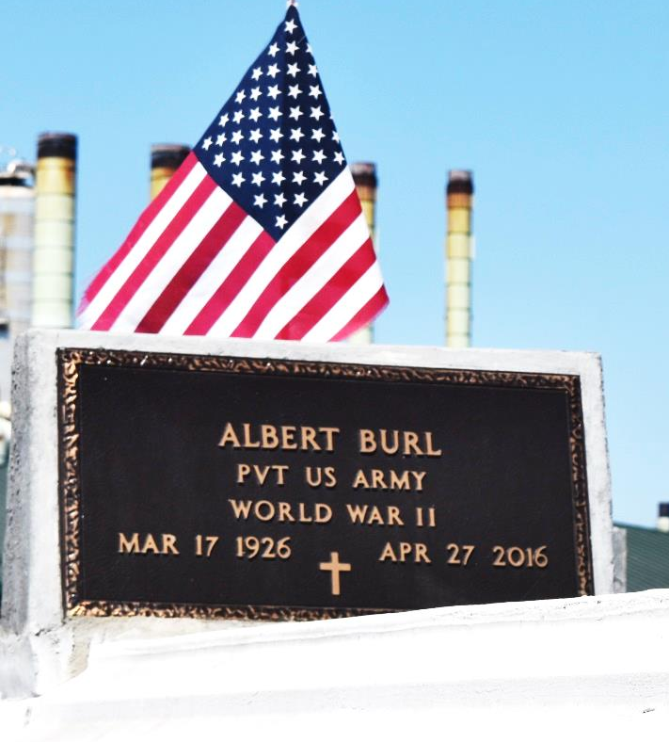

Albert "Red Bill" Burl, Age 90, departed this life on Wednesday, April 27, 2016. Son of the late Johnny and Louisa Burl, husband of the late Lizzie Mae Burl, father of Linda Burl Johnson, Albert (Pa) Burl, Lilac Burl Rixner, Rainere Burl London, Cherry Burl Frank and the late Mona Lisa Burl Smith, Alan (Pt) Burl Sr, and Regina Burl. Survived by his brother Huey P. Fleming Sr., and a host of grandchildren, great-grandchildren, great-great-grandchildren, nieces, nephew other relatives and friends. Wake service on Thursday, May 5, 2016 at True Light B.C., 258 S. Little Hope St. Garyville, La 70051 at 6:00pm, Rev. Wesley Anderson Sr. Pastor; Funeral service on Friday, May 6, 2016 at 10:00am at New Zion Christian Center, 216 W. Main St. Gramercy, La 70052, Rev. Emil Dean Mitchell, Pastor, Bishop Ronald Frank Officiating. Viewing: Albert will lie in state at Hobson Brown Funeral Home on Thursday, May 5, 2016 from 12:00noon until 4:00pm and on Friday, May 6, 2016 at 8am until religious services at 10:00am Interment in Zion Travelers Cemetery, Reserve, LA. Services entrusted to Hobson Brown Funeral Home & New Orleans Embalmers Association.

Advocate, The (Baton Rouge, LA) - Tuesday, May 3, 2016
Contributed by Jane Edson

