Helen (Rixner) Burl
June 7, 1930 – November 21, 2011

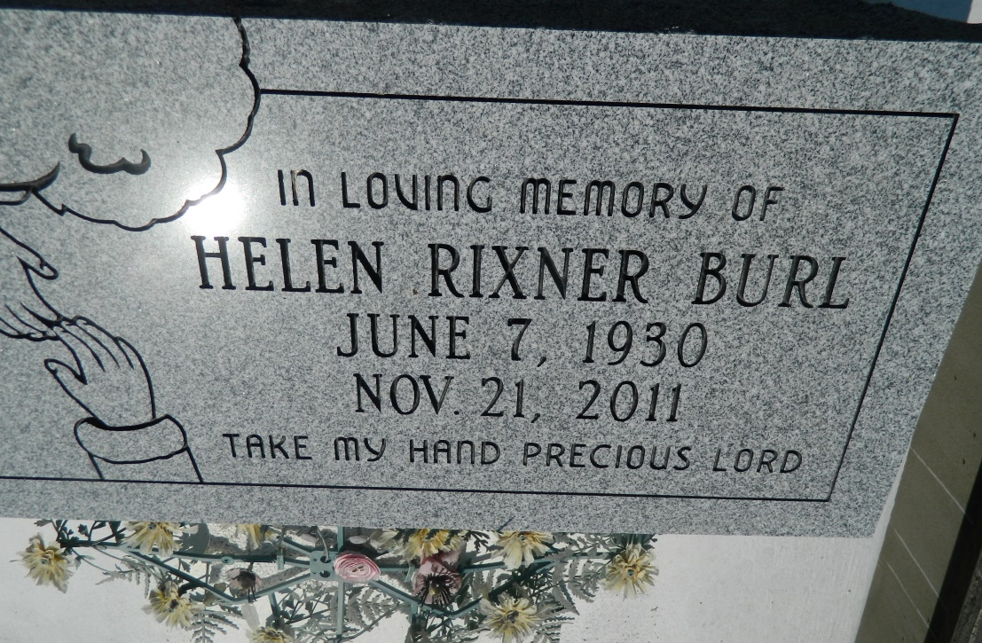

Helen Rixner Burl departed this life on Monday, November 21, 2011 in Mt. Airy, LA, at the age of 81. Wife of Herbert Burl, Jr. Mother of David Burl, Sr., Barbara Burl Foster, Pollet Frazier, Darrin Burl, the late Dianne B. Trucuit and Chuckle Burl. Sister of Cornelius Rixner. Also survived by 17 grandchildren, 36 geat-grandchildren and 5 great-great-grandchildren.
Relatives and friends are invited to attend the visitation and Funeral Service at St. Mark Baptist Church, 132 Marquez Street, Mount Airy, LA 70076 on Saturday, November 26, 2011 at 10:00 a.m. Elder Oscar R. Nelson, Sr., Pastor, officiating. Interment in Zion Travelers Cemetery, Reserve, LA.
Service Entrusted to: HOBSON BROWN FUNERAL HOME, Garyville, LA 70051, (985) 535-2516.

Times-Picayune, The (New Orleans, LA) - Saturday, November 26, 2011
Contributed by Jane Edson

