John Borne Carter Sr.
October 26, 1920 – July 19, 2015

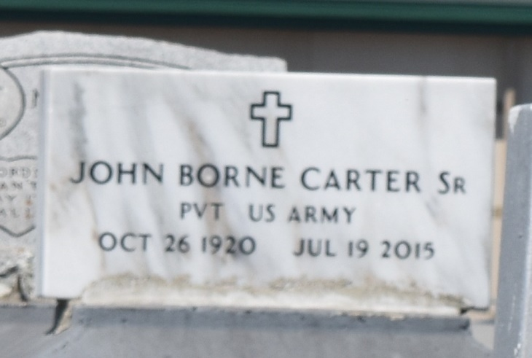

John Borne Carter, Sr., age 94 peacefully entered into eternal rest on Sunday, July 19, 2015. Beloved husband of the late Mary J. Carter. Son of the late Richard and Alice Carter. Father of Pastor David B. (Carroll) Carter, Nancy (Nathan) Carter, Norma Jean (Robert) Walker, John B. Cater, Jr., and the late Michael (Marva) Carter and Mary Ella (Robert) McKinney. Also survived by a host of grandchildren, nieces, nephews, cousins, other relatives and friends.
Family and friends are invited to attend the funeral at The Baloney Funeral Home, LLC, 1905 W. Airline Highway, Laplace, La. on Saturday, July 25, 2015 for 11:00 a.m. Visitation will be from 8:30 a.m. until time of service. Pastor Victor Simon will be officiating. Interment will be at Zion Travelers Cemetery, Reserve, La. Care of our father was entrusted only to the professionalism of The Baloney Funeral Home, LLC. Condolences can be expressed at www.baloneyfuneralhome.com.
Times-Picayune, The (New Orleans, LA) - Wednesday, July 22, 2015
Contributed by Jane Edson

