Gregory Clark Sr.
January 15, 1954 – July 23, 1999

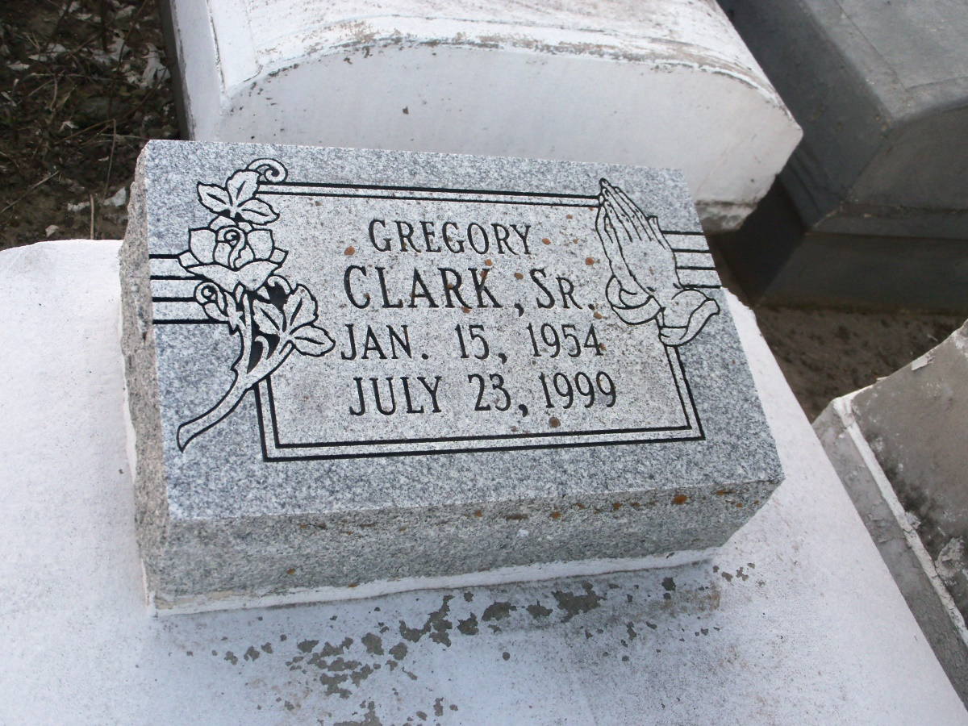
Photo by GeniHound

GARYVILLE - Gregory "Wheel" Clark Sr., 45, a native and resident of Garyville, died July 23. He was the husband of Deborah Pidgeon Clark and father of Gregory Jr. and Brandon Clark. He was also the son of Earl Clark Sr. and the late Annie Penn Clark and brother of Earl Jr., Edward, Wilfred, Johnny, Barry and Rosalie Clark. He is also survived by two grandchildren. Services are today at 11 a.m. at True Light Baptist Church, Garyville, with interment at Zion Travelers Cemetery, Lions. Visitation starts at 9 a.m.

L'Observateur, LaPlace, LA; July 28, 1999

