Beulah Corine (Steib) Clofer
October 23, 1914 – March 2, 2004

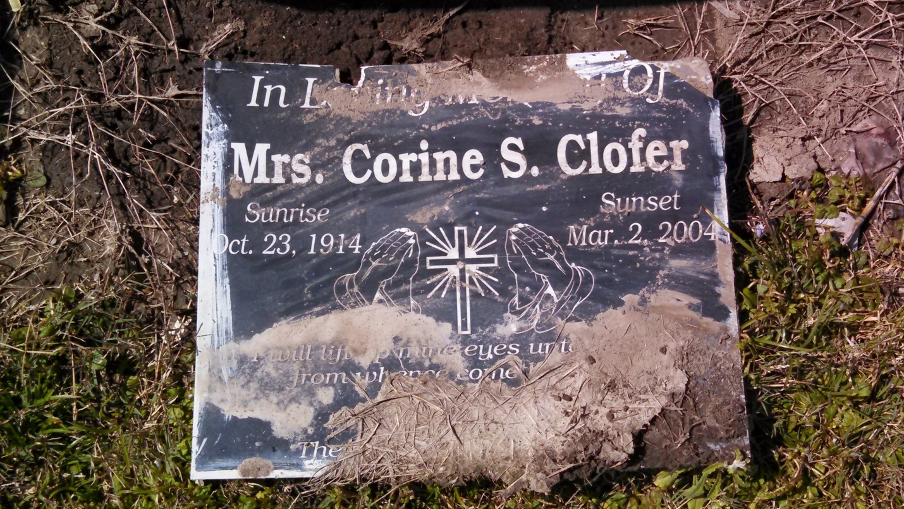
Photo by GeniHound

GARYVILLE - Beulah Corine Steib Clofer, 89, a native of Vacherie and a resident of Garyville died March 2.
She was the wife of the late Algernon Clofer, Sr., and the mother of the Harold Clofer, Lanne Haywood Clofer, Milton Clofer, Velma Poche, Betty Love, Hazel Clofer and Eva Sealy.
She was also the daughter of the late Corine Cooper Steib and Leonard Steib, and the sister of Henry Steib, Ulysses Steib, Melvin Winchester, Leona Pierre, Lorraine Jack and the late Leonard Steib.
She is survived by a host of grandchildren, great and great great grandchildren.
Services are today at noon at True Light Baptist Church, Garyville, with interment at Zion Travelers Cemetery, Lions. Visitation starts at 10 a.m.

L'Observateur (La Place, LA) - Friday, March 5, 2004
Contributed by Jane Edson

